|  |  |
| --- | --- |
|  | **Friday 28 April**  **Red Dot Book Award**  **One Minute Book Talk House Competition** |

To culminate our focus on the Red Dot Book Awards this year each House is invited to put together teams of up to 8 readers to compete in this event. The competition will be held in the **Junior School Multi-Purpose Room (J3-16) on Friday 28 April** during the following periods :

|  |  |  |
| --- | --- | --- |
| Year 7 | Period 4 | Books for Older Readers |
| Year 8 | Period 3 | Books for Older Readers |

Contestant will do a one minute ‘sell’ on the books for older readers pictured below. During this minute, without giving away spoilers, they will provide information about the book and tell us why we should read that book. Houses are encouraged to ensure they take the opportunity to promote each book in their category in order to maximise their score. However, each book can only be promoted once by each house. The house team size is restricted to 8 presenters but teams may choose to allow a house member to present multiple times discussing different books.

These talks will be judged according to the criteria below:

|  |  |
| --- | --- |
| **Scoring Criteria** |  |
| **Elements of talk** |  |
| Introduction   * Excellent - creative beginning which hooked the audience’s attention. * Good - attempt at hooking attention is made but beginning lacks a spark of excitement. * Needs improvement - introduction made but little attempt to grab the audience’s attention. |  |
| Title |  |
| Author |  |
| Genre |  |
| Summary   * Excellent – well organised and informative, provided interesting information about the book’s main events/ideas and some important details * Good – mostly organised and informative and provided relevant information about the book. * Needs improvement – somewhat organised but lacked detail information. |  |
| Point of interest   * Excellent - relevant and added depth and enjoyment to the talk . * Good – interesting and complemented the other information provided in the talk. * Needs improvement – included but added little to the audiences overall edification. |  |
| Recommendation   * Excellent – wrapped up well and provided a motivating reason for reading the book. * Good– mostly well done and identified who would be interested in reading this book and why. * Needs improvement – did identify who would be interested in reading the book but did not expound an why. |  |
| **Presentation of talk** |  |
| Poise   * Excellent- appeared calm and confident. There were no distracting behaviours. * Good - seemed calm and confident. Only one or two minor things were noticed, but they were not distracting to the listeners. * Satisfactory - mostly seemed poised. A couple of major distracting behaviours which would have bothered the listeners. * Needs improvement - wriggly or stilted and not at all poised., quite a number of distracting behaviours.. |  |
| Voice   * Excellent- voice was just right for the space—not too loud or too soft. Every word was heard – no mumbling or blurring of words. * Good - voice was just right for the space. A couple of words were mumbled or blurred together. * Satisfactory - spoke a bit too softly or too loudly. Several times, words were not clear. * Needs improvement- audience had a difficult time hearing the talk. Many words were not understandable because of mumbling. |  |
| Life   * Excellent - lot of feeling in the voice. Evidence of emotion, passion, excitement, sadness, etc. The talk was really engaging. * Good - some feeling in the voice and several parts of the speech really came alive for the listener. * Satisfactory - one or two places where talk seemed to come alive, but limited evidence of feeling in voice. * Needs improvement - no life in the speech. Spoke in a monotone and didn’t put any emotion into any part of the talk. |  |
| Eye Contact   * Excellent - constantly looked at your audience. Looked at each member of the audience. Barely or no use of notes. * Good - mostly looked at the audience but some members of the audience may have been missed because speaker only looked in certain directions. Note cards used well or rarely relied on at all. * Satisfactory - only occasionally looked at the audience. Many audience members were never looked at. Relied heavily on notes. * Needs improvement - Never looked at anyone. Relied very heavily on notes. |  |
| Gestures   * Excellent - very effective use of hand, face, and body gestures as well as motion which added to the talk. * Good - some use of gestures that contributed to the talk. * Satisfactory - gestures used once or twice. * Needs improvement – no gestures used. |  |
| Speed   * Excellent - not too fast or too slow. Varied speed well —faster for exciting parts, slower to add emphasis. Used pauses to let main points sink in with the listeners. * Good - not too fast or too slow but delivered the talk at one speed. No use pauses. * Satisfactory - spoke a little too fast or too slow. * Needs improvement - spoke way too fast. There was no change of pace. |  |

Students are encouraged to use the planning document below when preparing their talk and as element of differentiation should include discussion about a point of interest. These might include one of the following or a contestant’s original idea.

**Possible Point of Interest Options**

* Do some research on the author and tell us about other books he/she has written.
* Explain why you chose to promote that book.
* Tell us about the **setting**. Where and when did the story take place?
* Who is the main **character** in that book? Describe him/her.
* Was there a **conflict** or struggle that the character had to overcome?
* What was the **mood** of this novel: funny, sad, exciting?
* What was the **theme**? (The central idea or lesson about life that the author wants to know.)
* Why did you like it? What do you remember most about the book?
* You may want to read a passage from your novel: an interesting quotation, a piece of good description or a memorable line or paragraph.
* Or your own idea …

**Red Dot Older Readers:**

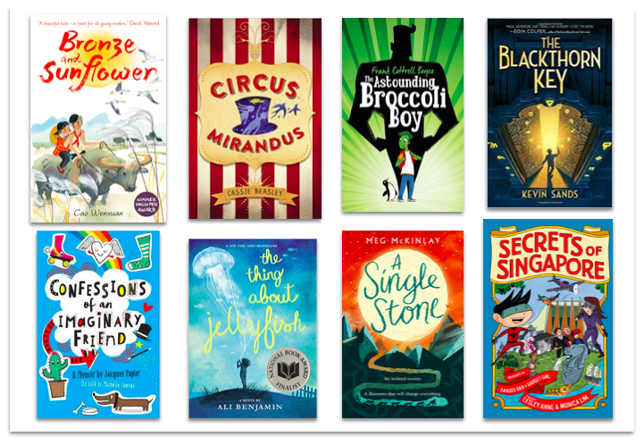

**Planning the One Minute Book Talk**

Name: ___________________________________ Tutor Group: ________ House: ____________________________

Red Dot Book: _________________________________________ Author: ____________________________________

|  |  |
| --- | --- |
| Time  (in seconds) | Information |
| 0 to 10 | Catchy introduction: __________________________________________________________________  ___________________________________________________________________________________  ___________________________________________________________________________________  ___________________________________________________________________________________ |
| 11 to 21 | Title, author, genre: __________________________________________________________________  __________________________________________________________________________________ |
| 22 to 45 | What the book is about:_______________________________________________________________  __________________________________________________________________________________  __________________________________________________________________________________  __________________________________________________________________________________  __________________________________________________________________________________  Point of Interest :  __________________________________________________________________________________  __________________________________________________________________________________ |
| 46 to 60 | Who should read this book and why: ____________________________________________________  __________________________________________________________________________________  __________________________________________________________________________________ |