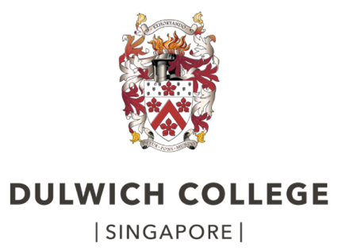

**History Department**

**IB Diploma**



**Course Companion**

As a student of history in an international school, the study of history from an international perspective is increasingly important today. Past atrocities are airbrushed from school history textbooks, countries develop diplomatic relations after years of isolation and nations wage war against one another with ‘history’ as their justification. With globalization and technological developments, different cultures and societies are more reliant on each other than ever before. Clearly there is a need for an understanding of the present as well as the past, but more importantly the impact that the past has on our present.

What is the role of history and the historian in society? Does the historian record history or create it? Can the historian be free of bias in the selection and interpretation of material? These are just some of the questions that the study of history poses.

**What are the aims of the I.B History Diploma Programme?**

* Demonstrate historical understanding of 20th century world history in breadth and depth and from different cultures
* Develop an appreciation of History as a discipline
* To have an international awareness of people living in different places at different times
* To promote a better understanding of the present through an understanding of the past
* Above all, to develop historians by fostering a life- long interest in History

**How is the I.B History Programme Structured?**

* History is in Group 3: ‘Individuals and Societies’
* History is available at both ***Standard*** and ***Higher*** level
* Higher Level and Standard Level students **both** complete Paper 1 and Paper 2, while HL students **also** complete Paper 3. The table below summarises the assessment structure:

|  |  |  |  |
| --- | --- | --- | --- |
| **Title** | **Exam Paper** | **Exam Questions Focus** | **Weighting**  **SL HL** |
| **Prescribed Subject**  *‘The Move to Global War’* | Paper 1  ***SL & HL*** | Document Study  Answer all 4 Qs   * Inference * Content * Provenance * Sources/Knowledge | 30% 20% |
| **20th Century World History Topics**  *‘Authoritarian States (20th Century)’*  *‘The Cold War: Superpower Tensions & Rivalries (20th Century)’* | Paper 2  ***SL & HL*** | Broad Questions  2 x Essays in 90 minutes  (from different topics) | 45% 25% |
| **Historical Investigation** | Internal Assessment  ***SL & HL*** | Research Project  1500 - 2200 Words | 25% 20% |
| **Regional Option:**  **‘***Imperial Russia, revolution and the establishment of the Soviet Union (1855-1924)’*  **‘***European States in the Inter-War Years (1918-39)’*  *‘Diplomacy in Europe (1919-1945)* | Paper 3  ***HL Only*** | Focused Questions  3 x Essays in 150 minutes  (two essays can be from same topic) | 35% |

**Course Options and Exam Units**

The course is designed to take in a broad sweep of nineteenth and twentieth century history. There are four inter-related themes.

* The development of extreme nationalism and political ideologies across the globe in the modern period and the failure of the international system to navigate them peacefully.
* An analysis and evaluation of the subsequent rise and rule of authoritarian and single party states.
* An exploration of the challenges posed by the dramatically altered international landscape after World War II and the consequent development of the Cold War.
* Case studies exploring the failure of the international community to prevent conflict and ideological tension over the course of the twentieth century.

**Theory of Knowledge and History**

History is one of the eight *Areas of Knowledge* that are at the centre of the TOK course. It is an interesting area of knowledge because it raises questions such as how far we can speak with certainty about anything in the past, and whether historians’ accounts are necessarily subjective. All of the elements of the history course provide excellent scope for making links to TOK. However, the most explicit link to TOK comes in the internal assessment task. Students are required to reflect on what completing their historical investigation taught them about the role of methods used by, and challenges facing, the historian. This provides excellent links to TOK, where students will, for example, compare the methods used to gain knowledge in history with the methods used to gain knowledge in other areas of knowledge.

**SUMMARY OF SYLLABUS CONTENT**

**Paper 1: The Move to Global War** *(SL & HL)*

**Assessment: Source analysis and evaluation**

This prescribed subject focuses on military expansion from 1931 to 1941. Two case studies are prescribed from different regions of the world, and **both** of these case studies must be studied. The first case study explores Japanese expansionism from 1931 to 1941, and the second case study explores German and Italian expansionism from 1933 to 1940. The focus of this prescribed subject is on the causes of expansion, key events and international responses to that expansion. Discussion of domestic and ideological issues will therefore be considered in terms of the extent to which they contributed to the expansion, for example, economic issues, such as the long-term impact of the Great Depression, will be assessed in terms of its role in shaping more aggressive foreign policies.

**Paper 2: Twentieth Century World History** *(SL & HL)*

**Assessment: Analytical and evaluative essays**

**a) Single Party and Authoritarian States**

This topic focuses on exploring the conditions that facilitated the rise of authoritarian states in the 20th century, as well as the methods used by parties and leaders to take and maintain power. The topic explores the emergence, consolidation and maintenance of power, including the impact of the leaders’ policies, both domestic and foreign, upon the maintenance of power. Examination questions for this topic will expect students to make reference to specific authoritarian states in their responses, and some examination questions will require discussion of states from more than one region of the world. In order to make explicit links with the Higher Level topics, as well as to ensure two regions are studied, the authoritarian regimes selected for study are:

* Castro’s Cuba
* Mussolini’s Italy
* Hitler’s Germany *(IGCSE students can draw on their previous studies)*
* China under Mao *(IGCSE students can draw on their previous studies)*

**b) The Cold War: Superpower Tensions and Rivalries**

The Cold War dominated global affairs from the end of the Second World War to the early 1990s. This topic focuses on how superpower rivalries did not remain static but changed according to styles of leadership, strength of ideological beliefs, economic factors and crises involving client states. The topic aims to promote an international perspective on the Cold War by requiring the study of Cold War leaders, countries and crises from more than one region of the world.

**Coursework- Historical Investigation** *(SL & HL)*

**Assessment: 1,500 – 2,200 words, independent research assignment**

This is an opportunity for you to demonstrate your skills and knowledge in history, allowing you to pursue a topic of personal interest without the constraints of the syllabus or a written examination.

**Paper 3: Higher Level Regional Option: Aspects of the History of Europe** *(HL ONLY)*

**Assessment: In depth analytical and evaluative essays**

This paper encourages a depth study of a particular world region, in our case Europe. You will encounter some entirely new history through the focus on the history of Russia, pre/post war Spain and Great Britain, while the subsequent study of Cold War conflicts in the region will dovetail with aspects of your SL studies. Those of you who completed History IGCSE will benefit from an overlap with aspects of the unit on Germany 1919-45, but be assured that you will also be stretched and challenged by a wealth of new material and perspectives.

You are required to study three topic areas. The topic areas we will cover are:

* **Imperial Russia, revolution and the establishment of the Soviet Union (1855-1924)**

*The modernisation and conservatism in Tsarist Russia and the eventual collapse of the tsarist autocracy, as well as the revolutions of 1917, the Civil War and the rule of Lenin.*

* **European States in the inter-war years (1918-1939)**

*This section deals with* ***domestic*** *developments in certain key European states in the period between the two world wars. This unit will involve the study of the experiences of Germany, Italy, Spain and Britain.*

* **Diplomacy in Europe (1919-1945)**

*This section explores international relations in Europe from 1919 to 1945 with initial emphasis on the Paris peace treaties. The section covers attempts to promote collective security, the individual foreign policies of Italy, Germany, France, Britain and the Soviet Union.*

There will be 2 examination questions set on each topic area, and you will choose any 3 questions to answer in the exam. The course outline (overleaf) illustrates the sequence of learning for Year 12 and 13.

**Overview Structure of the Course: Standard (and Higher) Level Students**

|  |  |  |
| --- | --- | --- |
| **Year 12** | | |
|  | SL & HL (All students)  *6 lessons per cycle* | HL (Only HL students)  *3 lesson per cycle* |
| Michaelmas | **Authoritarian States*****(Paper 2)*** | **Imperial Russia, revolution and the establishment of the Soviet Union (Paper 3)** |
| Lent | **The Move to Global War *(Paper 1)*** | **Imperial Russia, revolution and the establishment of the Soviet Union (Paper 3)**  *Continued*  **Europe states in the inter-war years – *Britain* (Paper 3)** |
| Trinity | **The Move to Global War *(Paper 1)***  *Continued*  **Internal Assessment *(Independent research coursework)***  *N.B. Begins end of Lent term* | **European States in the inter-war years – *Spain* (Paper 3)** |

|  |  |  |
| --- | --- | --- |
| **Year 13** | | |
|  | SL & HL (All students)  *6 lessons per cycle* | HL (Only HL students)  *3 lesson per cycle* |
| Michaelmas | **The Cold War: Superpower Tensions and Rivalries - (Paper 2)** | **Diplomacy in Europe (Paper 3)** |
| Lent | **Revision Time** | **Diplomacy in Europe (Paper 3)**  *Continued*  **European States in the inter-war years – *Germany/Italy* (Paper 3)** |

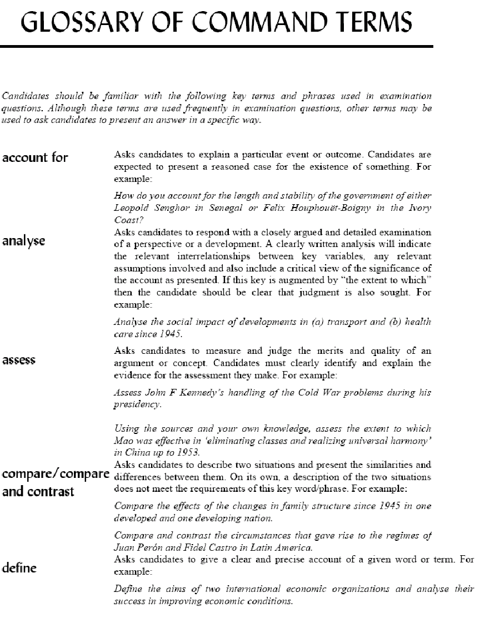

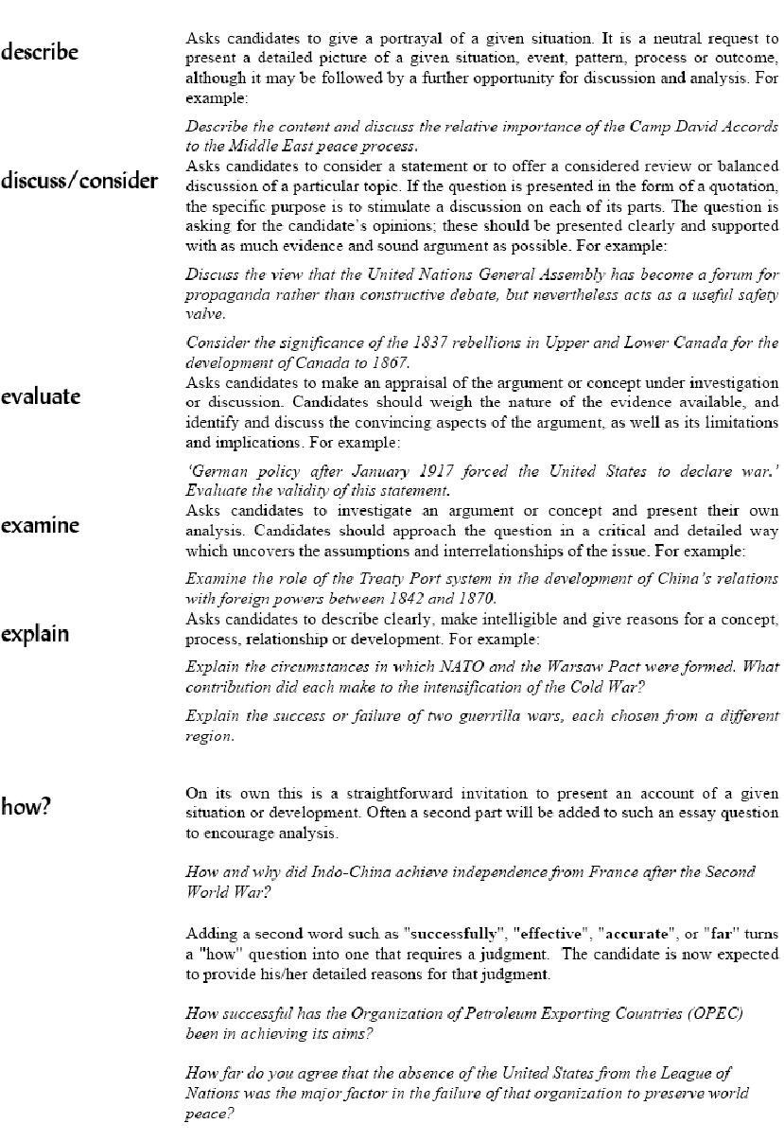

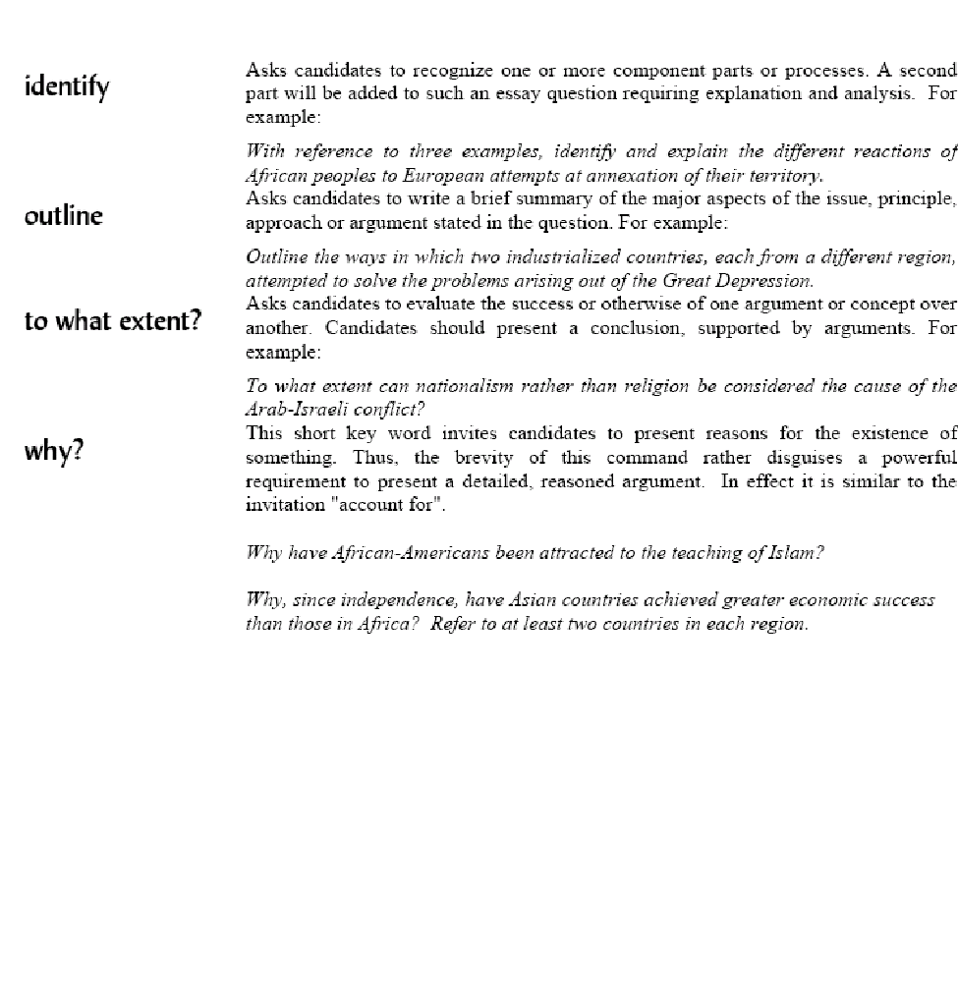

**A Glossary of Key Words for the I.B Diploma Level Historian**

**There are many more. You should aim to add to these over the two years!**

**AGRARIAN: landed, agricultural**

**ANNEXE: to take over another country**

**ARBITRARY: unrestrained; exercising power without justification or legal backing**

**AUTARKY national economic self sufficiency**

**AUTOCRACY all powerful rule by one leader usually supported by the theory of divine right- e.g. the Tsars**

**CAPITALISM: used in a general way by historians to describe the kind of economic system that has existed for at least the last 100 or 200 years since the time of industrialisation. In Marxist terms there is a more precise meaning. Marx thought that capitalism is the social order which succeeded feudalism, having overthrown it and is now subject to overthrow by the working class or socialist revolution.**

**CABINET- group of ministers chosen by the Prime Minister to be responsible for different areas of government policy**

**CHARISMA: a term coined by the German sociologist Max Weber meaning the almost magical qualities of attractiveness possessed by certain political leaders**

**CHILIASTIC: believing in the coming of a new world or a messiah**

**CLASS: as generally used by historians it means the broad groups into which families and individuals in modern society divide. These groups fall into a rough hierarchy according to wealth, influence and power. It is a term which again used more precisely by Marxists who link class to the ‘mode of production’.**

**COALITION: a combination. a government formed from more than one political party**

**CONSERVATIVE : in favour of maintaining systems in society and government as they are; opposed to radical change (also in Britain a political party)**

**CONSTITUTION: document laying down the basic principles or laws for the running of a country**

**COUNTER-FACTUAL HISTORY: a form of history in which the historian works out what would have happened if one particular factor or decision had been different- in its crudest form- what if Hitler had won WW2? at its most impressive in economic history- e.g. the building of railways in the USA**

**COUP D’ ETAT literally a blow or strike; sudden seizure of power by a small group- sometimes called a putsch**

**CULTURE: a) the entire network of activities, practices and institutions within a society b) the artistic and leisure activities and products of a society c) arts, entertainments media and books!**

**DEMAGOGUE: leader who appeals to the masses and who stirs up popular feeling. Usually exploits the prejudices of the masses.**

**DESPOT: a tyrant**

**ELITE: powerful groups at the top of society; ruling family, Church leaders, Military leaders, landowners, industrialists**

**EMANCIPATION: setting free**

**FRANCHISE: the right to vote in elections**

**FEDERAL: central government of a state divided into smaller units which also have a large amount of power**

**HEGEMONY: the power or influence exercised over several countries by one country- e.g. in pre 1914 Europe one might talk of a German hegemony over eastern Europe**

**HISTORIOGRAPHY: the systematic study of historians writings about the past**

**IDEOLOGY: a group or system of ideas, values and beliefs (either of a society, a social group or a political party)**

**IDEOLOGUE: someone committed to a set of ideas or principles**

**IMPERIALISM: the system of thought and action belonging to the support pf the idea of empire, that is to say one country ruling over and exploiting others.**

**MARXISM: the approach to history developed by the German thinker Karl Marx stressed that history unfolds in a series of stages which after the phase of middle class capitalism will be replaced by the triumph of the proletariat and a classless society. Central to this historical process is class struggle.**

**MILITARISM: belief in and having admiration for the army and its values**

**MODERNISATION: often used to describe the complex network of developments which are held to be part of the modern world e.g. economic growth**

**MORATORIUM: to delay; a legal agreement to postpone legislation or a the payment of a debt**

**MYTH: a version of the past which usually has some element of truth in it, but which distorts what actually happened.**

**PETTY BOURGEOISIE- lower middle class ‘shopkeeping’ class of business men**

**PLEBISCITE- referendum or vote on a single issue e.g. entry into the Single European currency**

**RADICAL: literally ‘from the roots’ i.e. an extreme reformer, but the word has taken on different meanings- in the 19th century it actually meant a moderate liberal reformer- but widely used in connection with extreme change**

**REVOLUTION: overthrowing of existing system or set of ideas: in political history means more than a simple coup d’etat or change of ruler and always implies some change affecting more groups in society than simply the ruling society**

**PAPER 2 ESSAY MARK SCHEMES**

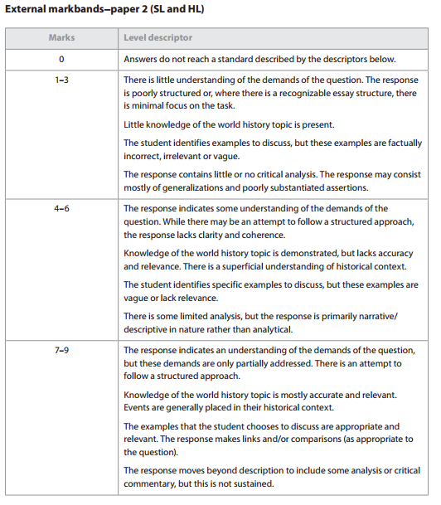

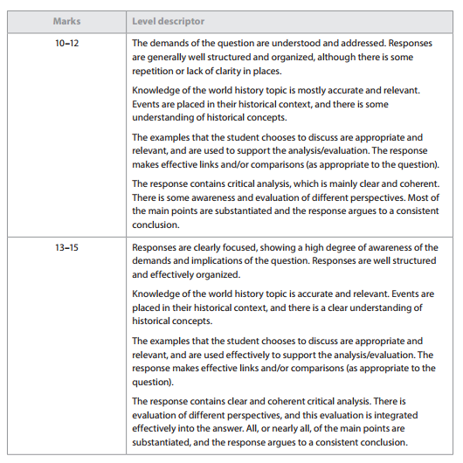

**PAPER 3 – ESSAY MARK SCHEME**

