ALICE CLARK-PLATTS

AUTHOR

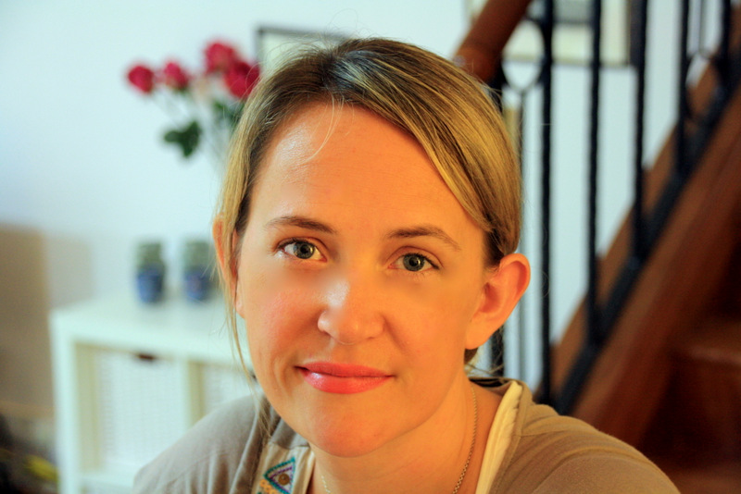

Alice Clark-Platts is an author whose novels are published by Penguin Random House.
Her first book, BITTER FRUITS, was released in 2015 followed by the e-book, TO DIE FOR. The next novel in the DI Erica Martin series – the best-selling THE TAKEN – was published the following year.
Alice’s books have been shortlisted for the Impress Prize and the Dead Good Readers’ Awards.
Alice also writes short fiction which has been published in various anthologies including the upcoming DEADLIER, published by Head of Zeus and edited by the crime writer Sophie Hannah.

Alice has taught a number of creative writing courses for writing groups; schools; for the National Arts Council of Singapore; and at Changi Prison with male inmates. Topics Alice has taught include short stories; plot; dialogue; crime writing; and playwriting. Alice has also appeared and moderated on panels at the Singapore Writers’ Festival and the Ubud Writers’ and Readers’ Festival in Bali.

Alice has a Masters in Human Rights Law and was a government lawyer for many years before becoming a writer.

If you would like Alice to teach at your institution, please contact her on aliceclarkplatts@gmail.com and/or +65 9838 5322.

