

**Friends of Dulwich presents…**

**Coffee and conversation with the author**

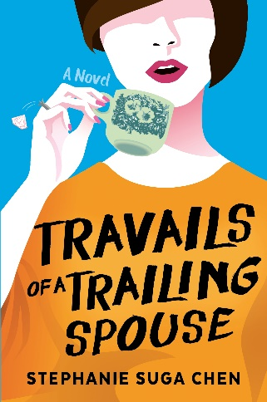



Come and chat with Stephanie Suga Chen, the

author of Travails of a Trailing Spouse.

She’ll be in the Senior School Library

**On** **Tuesday 15th May. At 8.45-10 am**

Tea and coffee served.

*For more information and RSVP online signup please visit the Parent Portal*

Debuting at #2 on the Straits Times bestseller list in Singapore

www.facebook.com/StephanieSugaChen