

**Friends of Dulwich presents…**

**Coffee and conversation with the author, Alice Clark-Platts**



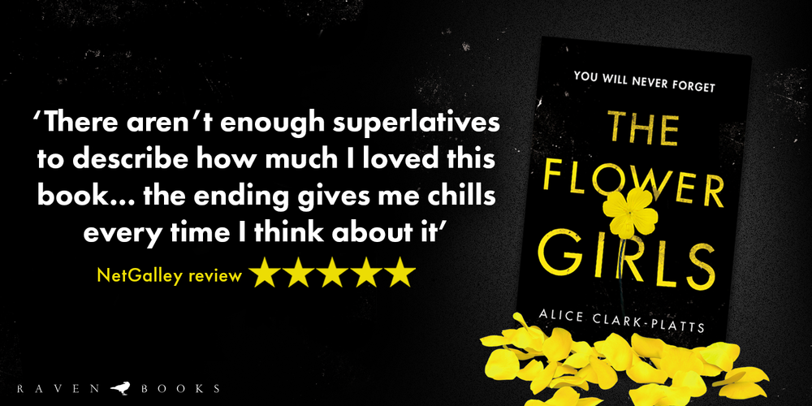

**RSVP** communicationsfod@dulwich-singapore.edu.sg

Alice, a former human rights lawyer, has worked on cases involving the rapper Snoop Dogg and Winnie Mandela.

Alice writes crime thrillers and short stories. Her recent book, *The Flower Girls*, was sold in a five-way publisher auction to Bloomsbury and has taken the book world by storm!

Don’t miss the opportunity to listen to Alice talk about her writing and hear the back story to this amazing new crime thriller.

**Please join us in the Senior School Library**

**Thursday 4 April at 8.45-9.45am**

**Tea, coffee and pastries served.**