

**Friends of Dulwich presents…**

**Coffee and conversation with the author, Andy Mulligan**

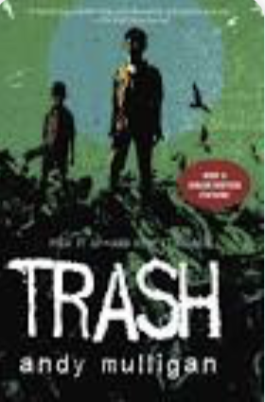 

Andy Mulligan, winner of the Guardian Children’s Fiction Prize, was brought up in South London. He worked as a theatre director for ten years before travels in Asia prompted him to retrain as a teacher. He taught English and Drama in India, Brazil, Vietnam, the Philippines and the UK. Andy works on a variety of media but is best known for his young adult fiction.

Andy will be at the Senior School Library

on

Thursday 6 December at 2.45 – 3.30pm

Tea and coffee served.

Email: [fod@dulwich-singapore.edu.sg](mailto:fod@dulwich-singapore.edu.sg) for more details

RSVP 