

**Friends of Dulwich presents…**

**Coffee and conversation with the author, Lisa Beazley**

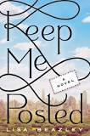

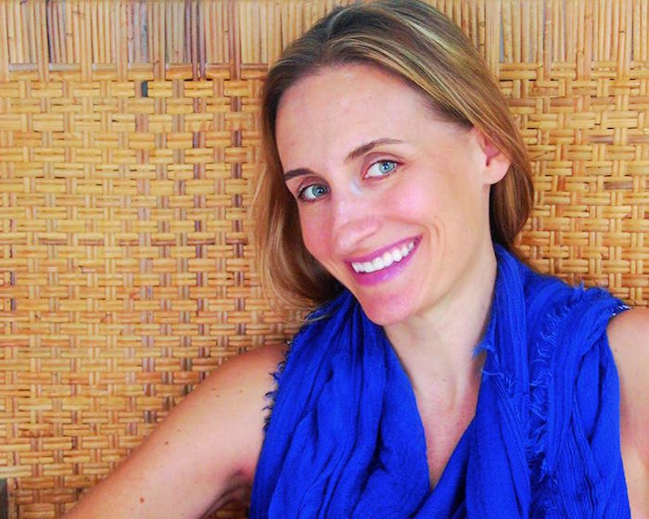

**RSVP** communicationsfod@dulwich-singapore.edu.sg

Lisa traded her corporate communications career for fiction writing when she moved from New York to Singapore with her husband and children. Born and raised in Toledo, Ohio, Lisa has a journalism degree from Ohio University and has lived and worked in Cleveland, Honolulu and New York City. When she’s not reading or writing, she is sharpening her toad-catching, Lego-building and deep-breathing skills as the mother of three young boys. *Keep Me Posted* is her first novel.

**Please join us in the Senior School Library**

**Tuesday 7 May at 8.45-9.45am**

**Tea, coffee and pastries served.**