|  |  |
| --- | --- |
| **Name:** | |
| **School:** | |
| **Class:** | |
| **QTY** | | |
| **The Sunshine Kid**  **$20** |  | |

Please bring your money in on the day

and ask Harry to sign your book.

**Have a great day!**

**About Harry Baker & Book Order Form**

Harry Baker's debut collection follows the narrative of his 5-Star Edinburgh Fringe shows, Harry Baker's Super-Amazing Mega-Awesome Gap Year Adventures: Birth of a Champion and Proper Pop-Up Purple Paper People. It details the journey from performing Jay Z-Maths parodies in school competitions to representing his country in Paris and becoming the youngest ever World Poetry Slam Champion. The Sunshine Kid contains the raw honesty, tongue-in-cheek humour and blistering wordplay that have characterised his live performances and won the hearts and minds of audiences all across the globe.

*“He's a champion.”* - Ed Sheeran  
*“Seriously - The greatest thing I have ever seen.”* - Scott Mills Show, BBC Radio 1

Restocked and loaded for 2015 — if your New Year's resolution was to read more, or be funnier and better looking, or support a young boys dream of becoming a professional writer* then buying this book will fulfil at least one of the above. Reading it will fulfil another. Tell your friends about it and in my eyes you're 3 for 3 — I'll even sign it if you ask nicely. Thank you!

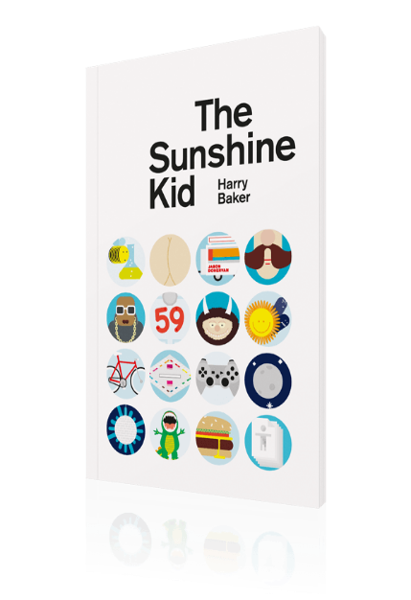



2010 London Slam Champion

2011 UK and European Slam Champion

2012 World Slam Champion

**Dear Parent / Guardian**

On……………………………..We are delighted to be visited by World Slam Poetry Champion, Harry Baker, and offer copies of his book – The Sunshine Kid - for sale to our pupils.