

**Friends of Dulwich presents…**

**Coffee and conversation with the author, Aysha Baqir**

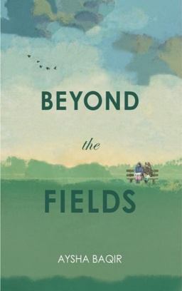 

Growing up in Pakistan, Aysha Baqir attended Mount Holyoke College on scholarship to study International Relations. A passionate advocate of economic development, she founded the not-for-profit Kaarvan Crafts Foundation in 1998 to provide business development and market-focused training for women in Pakistan. She currently resides in Singapore.

Aysha will be here to talk about her book, *Beyond the Fields,* which is set in the early 1980s against the backdrop of marital law and social turmoil. It is a riveting, timely look at profound inequalities, traditions that disempower women in our world, and survival as a dance to the beat of a different future.

Come and chat with Aysha Baqir.

She’ll be in the Senior School Library

**On** **Tuesday 19 March at 8.45-9.45am**

Tea and coffee served.

*RSVP: Communicationsfod@dulwich-singapore.edu.sg*