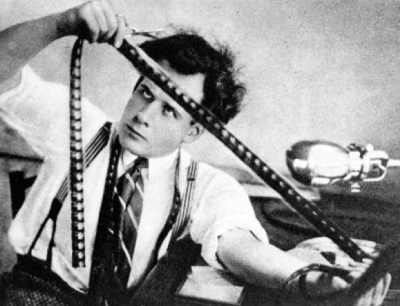**Micro Analysis**

**Editing**

**The Importance of Editing**

**Editing constructs the narrative**

Editing involvesthe selecting and joining together shots to create a finished film.

The film editor establishes the **pace and structure** of a film by connecting shots to create scenes. The shots the editor chooses and the ways they are combined set the **mood, develop the action,** create the **rhythm,** establish the film’s time and space, and guide the viewers’ attention. Editing creates moments of **drama, rises and falls, climaxes, juxtapositions, parallels, comparisons.**

**The editor controls:**

* Shot length
* Shot sequence
* Scene pace and rhythm
* Spatial and temporal relationships
* Audience viewpoint

**Editing and Audience Positioning**

* Editing can **foreground**, or **privilege**, the viewpoint of one character over another, making the audience identify more closely with that character.
* Editing can control the **audience’s access to narrative information** – the insertion or omission of certain shots creating a **restricted** or **unrestricted narrative**.
* Editing can **position** the **spectator** in the **diegesis** (film world), controlling what is seen, when and for how long.
* **Editing style** can make the viewing experience immersive (**continuity** editing) or jarring (**disjunctive** editing).

**Editing Style and Film Genre**

* **Editing style** can suggest a certain film **genre.** For example, social realism often uses **long takes** to create a **slow pace** and thereby heighten **verisimilitude**, or realism, as events seem to unfold in real time.

**Editing and Socio-Historical Context**

* Editing style can be linked to a particular **historical context** (post-MTV fast editing style developed in the 1980s) or **institution context** (cutaways from acts of sex or violence were a legal requirement pre-1960s).
* **Average shot lengths** on films made in the early part of the 20th century were much longer than they are today.
* **Intensified continuity editing** is the dominant style in contemporary Hollywood (camera moves constantly, shot distances shift and change, an average shot length of two or three seconds).

**Editing and Time**

* Editing can **extend** time to create **suspense** and **tension**.
* Editing **can compress** time, cutting out non-essential parts of the story using **elliptical edits**.

**Editing Glossary**

**Editing Styles**

* **Continuity editing:** In mainstream film classic continuity editing is often used. One shot leads smoothly and seamlessly into the next. It moves the viewer forward in time. Continuity editing aims to be unobtrusive and allows the viewer to become engrossed in the story. It is invisible editingthat flows smoothly across shots and scenes without jarring visual inconsistencies. It immerses the viewer in to the story.
* **Disjunctive editing:** Disjunctive editing draws attention to itself. It deliberately breaks all conventions of spatial, temporal, and graphic continuity to disrupt the flow of a scene. It makes the audience uneasy, often used at moments of emotional crisis or physical conflict.Jump cuts, flash frames, speed ramping, time-space disruptions are common disjunctive techniques.Disjunctive editing was made fashionable by the French New Wave directors in the 1960s.
* **Hollywood montage:** a way of compressing time, usually accompanied by music and dissolves – think the *Rocky* training montage.
* **Soviet montage:** Soviet Montage was used for political purposes. The juxtaposition of two images creates a new meaning.

A (a rich person) + B (a pig) = C (decadent swine)

**Production Process**

* **Post-production:** the phase after produciton where the film is edited and music and effects are added.
* **Dailies:** the day’s footage that is given to the editor.
* **Scene:** these are edited into scenes, a sequence of related shots.
* **Rough cut:** the editor's first pass at assembling the shots into a film, before tightening and polishing occurs.
* **Final cut: t**he finished edit of a film, approved by the director and the producer. This is what the audience sees.

**Continuity Editing Techniques**

* Continuity editing begins wide before moving in close.
* Scenes begin with an **establishing shot:** a shot, normally an extreme long shot or long shot that establishes where the action is about to occur.
* It follows the **180 degree** and **30 degree** rules to **organise space** in a way thatdoes not confuse the audience. If a person enters a front door, he/she arrives at a living room.
* **Match on action cut:** a cut joining two shots that show different views of a continuous action.
* **Split edits:** J-cut: audio begins, followed by image. L-cut: image begins, followed by audio. Establishes link between scenes.
* **Eyeline match edits:** In shot A the character looks and in shot B the audience sees what is being looked at.
* **Shot reverse shot:** usually used for conversation scenes, this technique alternates between over-the-shoulder shots showing each character speaking.
* **Insert shot**: camera cuts in on the main subject (mid shot man waiting to close-up of his watch)
* **Cut-away shot**: camera **cuts away** from the main subject (from actor waiting to car arriving).
* **Over-the-shoulder shot:** commonly used to establish continuity during dialogue scenes.
* **POV edits:** shot enables the audience to share the viewpoint of a character, thereby privileging their experience, understanding and view of the world.

**Disjunctive Editing**

* **Camera crosses the line**: breaking spatial continuity by ignoring the 180 degree rule.
* **Jump cuts:** a cut that creates a lack of continuity by leaving out parts of the action.
* **Time remapping effects:** Speed ramps, repetitions, time lapse, freeze frames, slow motion, fast motion, etc.
* **Flash frame** transitions

**Editing Transitions**

* **Straight Cut:** one shot edits to another (A+B+C+D).
* **Fade in/ fade out:** screen becomes usually black, or sometimes white. Typically used to indicate a passage of time, or to create a dramatic pause for the audience.
* **Wipe:** visible on screen as a bar travelling across the frame pushing one shot off and pulling the next shot into place. Rarely used.
* **Invisible wipe:** edit as a character or object passes in front of the camera. Creates the illusion of a long take.
* **Graphic Match:** Two shots have common visual/compositional elements. A dissolve from a fan to a helicopter rotor blade in *Apocalypse Now*.
* **Iris transition:** visible on screen as a circle closing down over or opening up on a shot. Seldom used in contemporary film, but common during the silent era of Hollywood films.
* **Fade:** a visual transition between shots or scenes that appears on screen as a brief interval with no picture. The editor fades one shot to black and then fades in the next. Often used to indicate a change in time and place.
* **Dissolve:** a gradual scene transition. The editor overlaps the end of one shot with the beginning of the next one.
* **Flash frame transitions:** a disjunctive transition caused by inserting one frame colour (usually white) between edits.

**Time and Place**

* **Linear chronology:** in time order, or sequence
* **Non-linear chronology:** not in time order, or sequence
* **Flashback/flashforward:** edit that move the narrative forwards or backwards in time.
* **Parallel narrative:** cutting between two, or more, simultaneuos events.

**Pace and Rhythm**

Rhythm is a fundamental tool of the editor. **Action sequences** often build slowly, with longer shots giving way to shorter, quicker shots. After the **climax**, shots begin to lengthen and slow, indicating to the audience that they can relax.

* **Fast-paced editing style** or **slow-paced editing style** affects the rhythm of scene.
* **Long take:** a shot that extends for an entire scene or sequence with no editing.
* **Fast cutting:** a series of short edits, sometimes called MTV editing. Common in action sequences.
* **Slow cutting:** Editor uses long takes to slow pace of film.
* **Speed ramping/slow motion/time stretching/fast motion:** different ways to manipulate the presentation of onscreen time.
* **Time compression: time-lapse effects** and **elliptical edits.**

**Soviet Montage Editing**

A theory that when images are juxtaposed a third meaning can be created (A+B = C). In revolutionary Russia, it was believed that film could there be used to communicate ideological messages to the masses and was used as a tool for propaganda by filmmakers like Sergei Eisenstein. Leve Khuleshov demonstrated the power of editing with his famous Mozhukhin Experiment which involved placing identical shots of a famous actor next to different images and then asking the audience to interpret what they saw. Each time the second image changed, so did the audience’s interpretation. This has become knownas the Khulshov Effect.

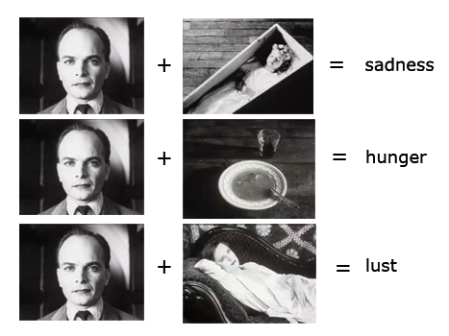

**Task:** Recreate the Mozhukhin Experiment and present you work to the class.

**The Function of Editing in a Chosen Sequence.**

**Editing and narrative are inter-dependent.** Editing controls the way an audience perceives relationships in sequence, space and time. Editing is integral to the plot of a film, enabling the filmmaker to create points of climax, tension and suspense. When analyzing a film, ask the following questions:

* How does editing create mood and atmosphere?
* Does the editing reveal something about particular characters or themes?
* Is the editing fast-paced or slow-paced?
* Does the length of shots remain consistent throughout the scene?
* Do events take place in real time, or are they compressed?
* Does the editing privilege a particular character, or invite us to make contrasts and comparisons between characters and their actions?
* Is the editing style typical of the particular genre?
* Is the editing in your scene typical of the film as a whole?
* Is the editing chronological or non-chronological?
* Is continuity or disjunctive editing utilised?
* How are transitions employed in the narrative?

**Task: Explore how editing changes at different points in a scene.**

|  |  |  |
| --- | --- | --- |
|  | Narrative Action | Describe and Comment on Editing Style |
| 1. | Equilibrium |  |
| 2. | Disruption |  |
| 3. | Rising Action |  |
| 4. | Climax |  |
| 5. | Resolution |  |

**Graphic Match Transitions, Cross Dissolves, Superimposition and Sound Flash Back**

|  |  |
| --- | --- |
| **A series of graphic match transitions** show that the ceiling fan is triggering Willard’s memories.  By **de-familiarising** the image of Willard by inverting it, using **slow motion effects** and a doleful **non-diegetic musical score**, Coppola establishes an intense mood. |  |
| **Superimpositions** give the audience access to Willard’s thoughts.  The **split screen effect,** with Willard’s face filling one half of the **frame,** creates a striking **visual signifier** of Willard’s haunted state of mind. |  |
| **Cross Dissolves** establish Willard’s disturbed state of mind. |  |
| **Sound Flashback:** The whirring of the helicopter blades acts as a sound bridge, connecting the present to the past. |  |
| **Practical:** To create these effects in your work, press **Control-V** to reveal the **Opacity timeline** – hover and drag the line down, or **Option-click** to create custom **key-frames**. You could also lower the opacity in the **inspector window** or use one of the **blend modes** (try screen). The **cross-dissolve transition** effect in the transitions menu might also help.  Composition is also very important in this scene – the balance between past and present images suggested by the **split screen effect**. This could be achieved by using the **crop tool** and the **mask tool** (feather the edges to blend images). | |

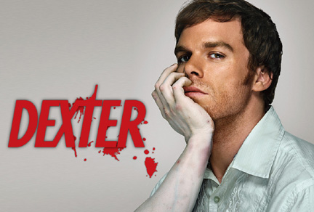

**Dexter**

Dexter is a serial killer who works as a blood analyst in a Miami CSI lab. From childhood, he has been trained to control his impulses to kill the innocent. He now tortures and murders only those he recognises as being like himself. Dexter’s hides his true identity from those he loves – his step-sister and girlfriend.

* Watch the opening credits, and then discuss how micro elements are used to create an impression of Dexter and the life he leads.
* What are the director’s intentions with regard to spectator response and positioning?

You might like to consider the following:

* Framing and composition
* Focus: deep/shallow/racking
* Editing: jump Cuts – length – transitions – sequence (linear/non-linear) and control of time (compression and expansion)
* Anchorage through titles
* Camera shot, movement, angle
* Lighting and colour
* Diegetic and non-diagetic sound.
* Performance
* Mise-en-scene

Introduction

* Briefly identify institution (Showtime, US cable company), production context, (pay-for-view TV series), audience (adult –graphic content) genre (hybrid genre, combining the police procedural/horror).
* Introduce sequence for analysis. What form (opening titles)? Function (establish genre/character/tone of show)?
* Identify the director’s intentions with regard to spectator response and positioning?

|  |  |  |
| --- | --- | --- |
| **How are micro elements used to create an impression of Dexter and the life his leads?** | **Evidence (brief description)** | **Explanation (suggests, creates, conveys, positions, shows, implies, reinforces, makes us, encourages us, constructs)** |
| **Performance** |  |  |
| **Editing** |  |  |
| **Sound** |  |  |
| **Cinematography** |  |  |
| **Mise-en-scene** |  |  |
| **Lighting** |  |  |

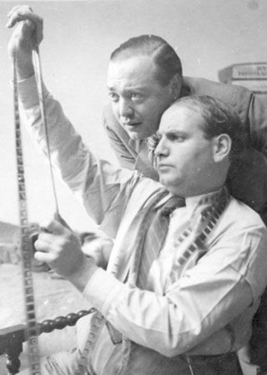 Film Studies

In order for you to get a better understanding of the rules of classical Hollywood continuity editing, make a short film that shows the effects of following the rules and of breaking them.

|  |  |
| --- | --- |
| Rule maker | Rule breaker |
| Over the shoulder shots – following the 180 degree rule | Over the shoulder shots –breaking the 180 degree rule |
| Shot- reverse shot, following the eyeline match rule | Shot- reverse shot, breaking the eyeline match rule |
| Establishing shot – long shot –mid shot –close-up | mid shot -long shot-close-up -establishing shot |
| Obey the 30 degree rule | Break the 30 degree |
| Record a mid shot monologue – replace three sections by inserting cut away shots. | Record a mid shot monologue and delete three sections. |
| Create a three-part match-on action edit, hitting someone in the face. | Break continuity with each shot: change actor positions, appearance and choreography. |
| Create a sound bridge to link a series of shots (e.g. the sound of running water). | Create a disjunctive series of edits by having different ambient sounds for each shot. |

**Task:** Edit your footage in Final Cut and present it to the class.

**Continuity: Match on Action Editing**

**Match on action** is when the editor cuts from one shot to another so that an action that begins in the first shot, continues and is completed in the second shot. This **cutting on the action** creates continuity.

For example, when an actor exits the frame from the left, he or she must enter the next shot from the right in order to match the screen direction. The actor must move at the same speed and maintain the same performance in order to make the edit seamless.

Certain genres, such as action films, can have highly elaborate match on action edited sequences.

In order to construct successful match on action sequences you must:

* **Rehearse** the shot with the actor to ensure speed, direction, movement, gesture and expression are consistent across shots.
* Place **markers** to help actor the hit his or her mark.
* If the sequence is going to be shot over time, record details of set, costume and position (ensure one member of the group records continuity details, perhaps by taking still images).
* **Shoot to edit** – in other words, anticipate how your shots will cut together in the edit.
* Follow the **30 degree rule**, moving the camera a minimum of 30 degrees for each shot to prevent jump cuts that will break continuity.
* Follow the **180 degree rule**, making sure your camera does not cross a predetermined line of action.

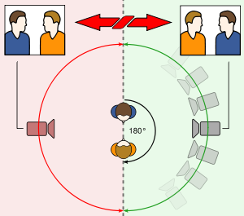

* Establish **eyeline matches** between subjects.

**Task**

Make a short sequence of shots to demonstrate your understanding of **match on action editing**.

* Brainstorm situations that involve movement.
* Storyboard your idea like the one below (hint: don’t do anything dangerous)
* Shoot and edit.
* Present your sequence to the class.

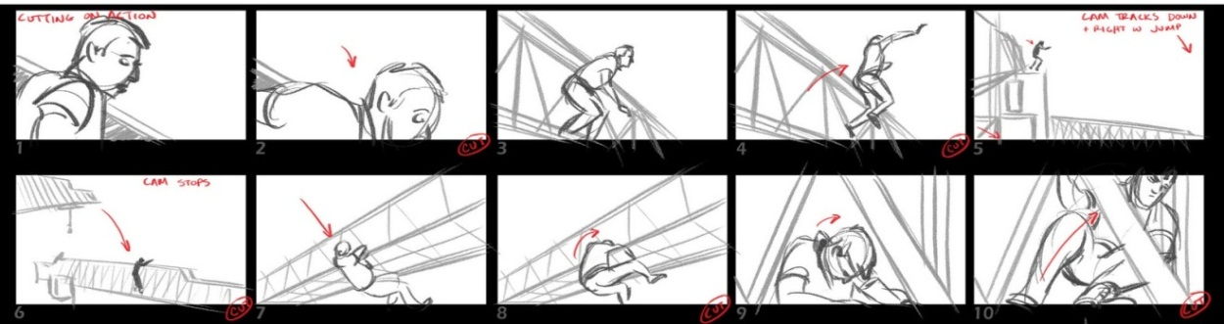

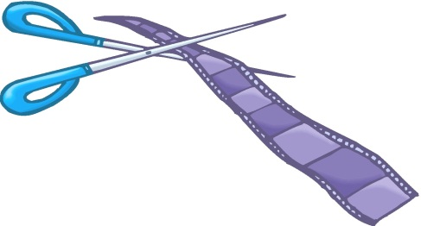**Temporal and Spatial Compression**

**Task: Make a short film that demonstrates the following techniques.**

**The waiting room.**

* A series of dissolves of a character pacing around a room, occupying different positions and sitting in different chairs.

**The moving clock**

* Two, or more, shots of a clock that dissolve into different hours.

**The training montage**

* A series of shots, often set to music, that represent a period of intense training or preparation.

**The Showdown**

* A series of fast cut close ups of the hero dressing for a confrontation.

**Fade to black**

* A fade to black is often used to signal the end of a scene and the passing of time.
* The fade to black can also be accompanied by the ticking of a clock, or another sound that suggests the passing of time.

**Time lapse**

* The speeding up of a continuous shot can create a time-lapse effect.

**The Journey**

* A long take, long shot of a character moving towards the camera is compressed by the use of a series of dissolves.

**The calendar**

* A close-up of a prop, often the pages of a calendar moving, or the

**The shadow**

* Shadow moving across an object to suggest the passage of the sun.

**Text**

* Adding text overlays or intertitles is often used to signal the passage of time, or a change of location (20 Years Later/Feudal Japan)

**Extension:** Create a short narrative called *The Quest* that incorporates as many of the above

techniques as possible.

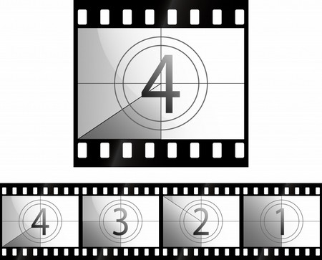

**Disjunctive Editing in The Passion of Joan of Arc**

