Film Studies

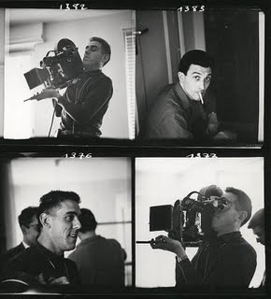

Cinematography

What is cinematography?

Cinematography can be divided into the following:

* Frame
* Shot
* Angle
* Movement

**Film Shot Analysis**

It isn’t enough to identify the shot type used by the director. You need to identify key compositional elements within the frame, consider the positioning of the camera and the arrangement of the subject in relation to the mise-en-scene. It is also important to consider the way in which the audience is invited to read the shot. How are we positioned in relation to character and event and what effect does this achieve?

Although not all of these elements will be relevant to every shot, it is important to consider the following:

* **Framing:** How does the way the scene is framed affect audience response? How does the director reframe during the length of the take?
* **Composition:** How has the filmmaker used shape, colour, negative space, patterning, etc?
* **Character blocking (proxemics):** Is there any significance in the relative size and placement of characters and objects?
* **Movement:** How do characters move into and around the frame? How does the camera move during the length of the shot?
* **Focal Point:** What is the main **focal point**? Why does the director make this the subject of the shot?
* **Lines of perspective**. How do leading lines direct the spectator’s gaze?.
* **Depth of field:** Do shallow focus, deep focus or racking focus add meaning to the scene? Does the juxtaposition of background and foreground add to the meaning communicated by the shot?

**Cinematography Terminology**

|  |  |  |
| --- | --- | --- |
| \\ttsfp01\mywork$\stevec\redirect\desktop\ttsfp01\vlcsnap-00016.png | \\ttsfp01\mywork$\stevec\redirect\desktop\ttsfp01\vlcsnap-00008.png | \\ttsfp01\mywork$\stevec\redirect\desktop\ttsfp01\vlcsnap-00015.png |
| Extreme Long Shot | Long Shot | Mid shot |
| \\ttsfp01\mywork$\stevec\redirect\desktop\ttsfp01\vlcsnap-00010.png | \\ttsfp01\mywork$\stevec\redirect\desktop\ttsfp01\vlcsnap-00004.png | \\ttsfp01\mywork$\stevec\redirect\desktop\ttsfp01\vlcsnap-00009.png |
| Close up | Extreme close up | Two shot |
| \\ttsfp01\mywork$\stevec\redirect\desktop\ttsfp01\vlcsnap-00003.png | \\ttsfp01\mywork$\stevec\redirect\desktop\ttsfp01\vlcsnap-00005.png | \\ttsfp01\mywork$\stevec\redirect\desktop\ttsfp01\vlcsnap-00007.png |
| POV shot | High angle shot | Low angle shot |
| vlcsnap-00017 | vlcsnap-00018 | C:\Documents and Settings\Stephen\Desktop\Lambs Shots\vlcsnap-00180.png |
| Shallow DOF (Background in focus) | Shallow DOF (foreground in focus) | Aerial shot |

|  |  |  |  |
| --- | --- | --- | --- |
| vlcsnap-00002 | | vlcsnap-00001 | C:\Documents and Settings\Stephen\Desktop\Lambs Shots\vlcsnap-00175.png |
| Canted angle/Dutch tilt shot | | Over the shoulder shot | Eye level close up shot |
| C:\Documents and Settings\Stephen\Desktop\Lambs Shots\vlcsnap-00176.png | | C:\Documents and Settings\Stephen\Desktop\Lambs Shots\vlcsnap-00177.png | C:\Documents and Settings\Stephen\Desktop\Lambs Shots\vlcsnap-00186.png |
| Tight close up | | Tracking shot (following) |  |
| C:\Documents and Settings\Stephen\Desktop\Lambs Shots\vlcsnap-00181.png | | C:\Documents and Settings\Stephen\Desktop\Lambs Shots\vlcsnap-00182.png | C:\Documents and Settings\Stephen\Desktop\Lambs Shots\vlcsnap-00187.png |
| Zoom | | | Tilt (top to bottom) |
| C:\Documents and Settings\Stephen\Desktop\Lambs Shots\vlcsnap-00183.png | C:\Documents and Settings\Stephen\Desktop\Lambs Shots\vlcsnap-00184.png | | C:\Documents and Settings\Stephen\Desktop\Lambs Shots\vlcsnap-00188.png |
| Pan (left to right) | | | Bird’s eye view shot |

|  |  |
| --- | --- |
| Straight-on angle | http://media.avclub.com/images/articles/article/30489/fightclub_jpg_595x325_crop_upscale_q85.jpg |
| Low angle shot | <http://images.starpulse.com/Photos/Previews/Slumdog-Millionaire-f09.jpg> |
| High angle shot | PussInBoots |
| Canted Angle/Dutch Tilt | http://www.brokenprojector.com/images/batmandutch.png |
| Extreme high angle Bird’s Eye View | Shawshank |
| Extreme low angle/ Worm’s Eye View | ShiningMurder |

**Racking/Pull Focus:** The foreground goes out of focus and the background comes in to focus (or vice versa). This technique steers the audience’s attention through the scene, a narrative device that links or invites contrast between two spaces or objects.

**Deep Focus:** When the foreground and the background are in focus. In these two shots from *Citizen Kane* (Orson Welles) all of the different planes of the image are given equal importance through deep focus.

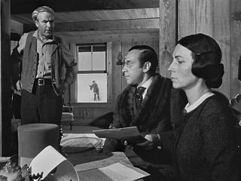 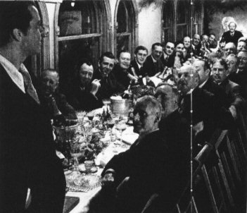

**Shallow Focus****:** A restricted *depth of field*, which keeps only the foreground or background in sharp focus. Used to direct the viewer's attention to one element of a scene. Shallow focus is very common in close-up.

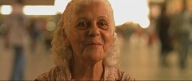  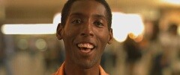

**Exposure****:** How much light is allowed into the camera. An overexposed is washed out. Conversely, an, underexposed image is dark. Exposure can be manipulated to guide an audience's response to a scene.

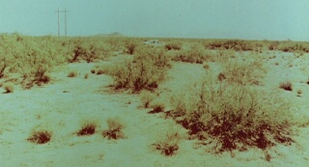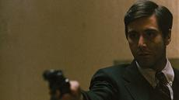

In his film *Traffic* (2000), Steven Soderbergh decided to shoot all of the sequences in the Northern Mexico desert overexposed. The resulting images give an impression of a barren, desolated land being mercilessly burnt by the sun. In *The Godfather(1972)* the underexposure suggests the dark and murky world of the gangster.

*Some material adapted from Yale Film School©*

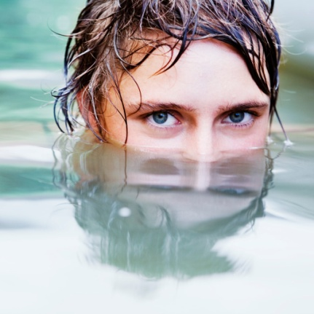**Audience Positioning and Mode of Address**

**Objective and Subjective Camera Positioning**

* A director can affect our emotional response to a character or action by the careful selection of camera position, choosing between the objective and subjective.
* An objective shot encourages the audience to adopt an observational and neutral, rather than participatory relationship with characters. The spectator voyeuristically watches the action.
* A **'subjective'** camera shows us events from a particular participant's visual point of view. A subjective shot encourages us to see/experience events from a particular character’s point of view, often by using POV shots, or by privileging one character’s point of view of the world over another’s. This first-person style is rarely sustained (or we would never see that character).
* **Selective point-of-view** is when we are mainly concerned with a single character but the camerawork is not subjective. The camera encourages us to identify with the hero, for example. When the director chooses a selective point of view, we need to consider its effect on the way we respond to what is happening on the screen. **Pseudo POV shots**, such as over the shoulder shots, are common.

**Non-diegetic Voiceover**

* **Voice-overs** are sometimes used for **first-person narration**, which can position the audience so that they identify with a particular character and his or her version of events – an **unreliable narrator** can result in **narrative misdirection**.
* Television programmes within the documentary genre frequently employ a **non-diegetic voice-over** which **directly addresses** the audience, as do television commercials.
* **Third-person narrative modes** in genres such as documentary are common.
* **Multiple narrators** and viewpoints are also possible.

**Mode of Address**

**Modes of address** differ in their **directness**, their **formality** and their narrative **point-of-view**.

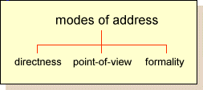

* On television, commercials frequently include a **direct mode of address** when the product sponsor looks into the camera; otherwise, a direct mode of address is largely confined to newsreaders, weather forecasters, presenters and interviewers.
* Direct address reflects the power of the speaker and typically signifies 'authority'. The head of state or the leader of a political party are amongst the few people allowed to look directly at the viewer, and then typically only within special genres such as a party political broadcast or an 'address to the nation'.
* In film, a **direct mode of address** is when a person appears [to look directly at the viewer](http://www.aber.ac.uk/media/Documents/gaze/gaze.html), breaking the so-called ‘fourth wall’. A direct gaze simulates **interaction** with each individual viewer
* Direct address is **rare** in the cinema, and when it is used it tends to be for comic effect as it **breaks continuity**, something mainstream films try hard to avoid.
* **Indirect address** is the principal mode employed in **conventional narrative**, which depends on 'the illusion that the represented participants do not know they are being looked at.

**Mode of Address and Camera Proxemics**

* Kress and van Leeuwen distinguish between 'intimate', 'personal', 'social' and 'public' (or 'impersonal') modes of address.
* In visual representation, **social distance** is related in part to apparent **proximity**, or distance.
* In camerawork, **degrees of formality** are reflected in shot sizes: close-ups signifying intimate or **personal modes**, medium shots a **social mode** and long shots an **impersonal mode**.
* The physical distance between the observed and the observer often reflects attempts to encourage feelings of **emotional involvement** or **critical detachment** in the viewer.
* **Proximity** is not the only marker of social distance in the visual media: **angles** of view are also significant. **High angles** (looking down on a depicted person from above) are widely interpreted as making that person look small and insignificant, and **low angles** (looking up at them from below) are said to make them look powerful and superior.

**Narrative Hierarchies of Knowledge**

* A **hierarchy of knowledge** refers to the amount of information given to audiences. This greatly affects the **spectator’s response**.
* **Restricted narration** is when information is deliberately kept hidden from the audience, or particular characters within the **diegetic world** (the film world). **Unrestricted narration** is when the audience is given access to knowledge of people and events. During a film, there is interplay between these two forms of narration.

Alfred Hitchcock famously explained the difference between restricted and unrestricted narration.

An unrestricted narrative creates suspense:

• We see a ticking bomb under a table. A group of characters enter the room and sit around the table.

A restricted narrative creates surprise:

• A group of characters enter the room and sit around the table. A bomb explodes

**Which modes of address are established in your chosen scenes? How is restricted and unrestricted narrative and objective and subject camera positioning, employed in the film you are studying? What meanings are conveyed?**

**Cinematography Analysis**

**Task: Create a visual reference sheet by selecting screen shots to show different aspects of cinematography. Try to find examples of all of the following:**

|  |  |  |  |
| --- | --- | --- | --- |
| **Extreme long shot**  **Long shot**  **Medium shot**  **Close-up**  **Extreme close-up**  **Two/Three shot**  **Reaction/Establishing**  **Shallow focus**  **Deep focus** | **Over-the-shoulder**  **Shot reverse shot**  **Eye level/straight-on angle**  **High angle**  **Low angle**  **Canted angle**  **Extreme high**  **angle/bird’s eye shot** | **Extreme low angle/worm’s eye shot**  **Canted angle/Dutch tilt**  **Aerial**  **Crane**  **Tracking**  **Hand held**  **Point of view (POV)** | **High key lighting**  **Low key lighting**  **Warm palette**  **Cool palette**  **Monochrome** |
| **Hint: Screen shots will often show multiple aspects of the above techniques. For example:** | | | |

In this image from French Neo-Noir *La Haine* (1995), the subjective POV and the eye-level shot create the effect that the pistol is aimed at the viewer which provokes a sense of anxiety and tension. The claustrophobic framing and the use of a tight three-shot make the characters seem unified but intimidating and aggressive to the outsider. The shallow depth of field focuses our attention on the emotionless faces of the young men while the use of a medium close up allows us to see the aggressive posture and body language. The monochrome film stock adds a sense of menace as is conventional of Film Noir.

[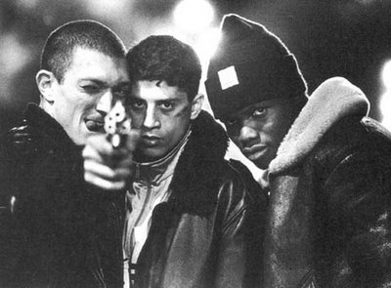](http://famousfrenchfilms.files.wordpress.com/2010/02/lahaine-screenshot1.jpg)**\*MONOCHROME**

**\*POINT OF VIEW**

**\*SHALLOW FOCUS ↔**

**\*EYE LEVEL**

**\*THREE SHOT**

**\*MEDIUM CLOSE UP**

**Chose about five of your screen shots and discuss the overall effect of the cinematography.**