**Year 9 Economics**

**End of Year examination 2023**

**Time allowed: 45 minutes**

**Name____________________________________________**

**Instructions:**

* Please answer all questions
* Answer the questions in the spaces provided
* Calculators may be used
* You are advised to show all your working out with your answer clearly identified at the end of your solution.

**Information:**

* The total mark for this paper is **41**.
* The marks for each question are shown in brackets

– use this as a guide as to how much time to spend on each question.

**Advice:**

* Read each question carefully before you start to answer it.
* Try to answer every question.
* Check your answers if you have time at the end.

**Q1.**

**Answer the question with a cross in the box you think is correct . If you change your mind about an answer, put a line through the box  and then mark your new answer with a cross .**

Which **one** of the following products has a price inelastic demand?

**(1)**

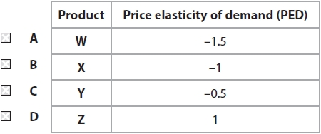

**Q2.**

What is meant by the term external costs?

**(2)**

.............................................................................................................................................

.............................................................................................................................................

.............................................................................................................................................

.............................................................................................................................................

.............................................................................................................................................

**Q3.  
Answer the question with a cross in the box you think is correct . If you change your mind about an answer, put a line through the box  and then mark your new answer with a cross .**

Which **one** of the following is an example of an occupation in the tertiary sector?

**(1)**

   **A**    Sheep farmer

   **B**    Factory worker

   **C**    Coal miner

   **D**    Sales assistant

**Q4.**Using the diagram below (on next page), draw the likely effects on the market for cars of the introduction of more effective technology in production. Label the new curve, the new equilibrium price and the new equilibrium quantity.

**(3)**

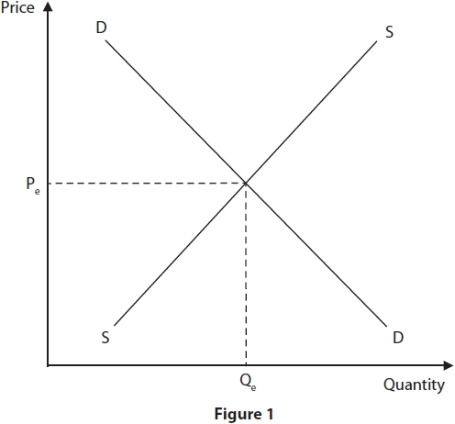

**Q5.** Figure 3 shows the demand for cocoa beans during 2019.

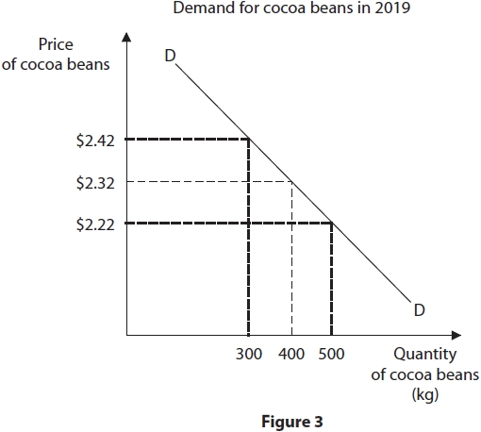

Explain **one** effect on the demand curve for cocoa beans following a change in the price.

**(3)**

.............................................................................................................................................

.............................................................................................................................................

.............................................................................................................................................

.............................................................................................................................................

.............................................................................................................................................

.............................................................................................................................................

.............................................................................................................................................

.............................................................................................................................................

**Q6.**An economy produces capital and consumer goods. This economy starts with unemployed resources at point X and then shifts to point Y where resources are fully employed.

In the box below, draw a production possibility curve (PPC) to show an economy moving from **point X** with unemployed resources to **point Y** where resources are fully employed.

**(3)**



**Q7.**Using the diagram below, draw the likely effects on the market for bread after a decrease in the population. Label the new curve, the new equilibrium price and the new equilibrium quantity.

**(3)**

**Q8.**Bespoke Bikes manufactures bicycles. Each worker produces bicycles from start to finish. Bespoke Bikes has decided to introduce a division of labour in the production of its bicycles.

(a)  What is meant by the 'division of labour'?

**(2)**

.............................................................................................................................................

.............................................................................................................................................

.............................................................................................................................................

.............................................................................................................................................

.............................................................................................................................................

(b)  Explain **one** advantage of the division of labour for Bespoke Bikes.

**(3)**

.............................................................................................................................................

.............................................................................................................................................

.............................................................................................................................................

.............................................................................................................................................

.............................................................................................................................................

.............................................................................................................................................

 .............................................................................................................................................

.............................................................................................................................................

**(Total for question 8 = 5 marks)**

**Q9.**Figure 4 shows some of the production costs in the month of May for a firm manufacturing football souvenirs in Qatar, in preparation for the 2022 World Cup.

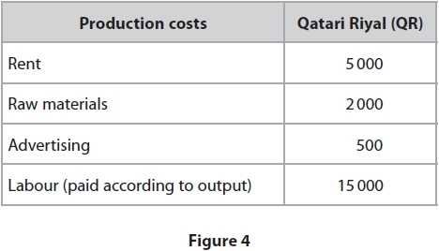

Calculate the **total variable costs** for the firm in the month of May. You are advised to show your working.

**(2)**

.............................................................................................................................................

.............................................................................................................................................

.............................................................................................................................................

.............................................................................................................................................

**Q10.**Young Tablet Covers is a firm based in Hong Kong. It produces colourful covers designed for children to protect their tablet computers. The quantity demanded and quantity supplied at different prices is shown in Figure 3.

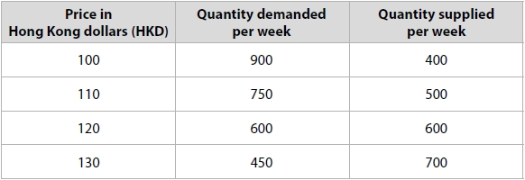

**Figure 3**

(a)  With reference to the data in Figure 3, what is the equilibrium price of a tablet cover?

**(1)**

   **A**    100 HKD

   **B**    110 HKD

   **C**    120 HKD

   **D**    130 HKD

(b)  With reference to the data in Figure 3, what is the excess demand or supply when the price of a tablet cover is 100 HKD?

**(1)**

   **A**    The excess demand will be 250 tablet covers

   **B**    The excess demand will be 500 tablet covers

   **C**    The excess supply will be 250 tablet covers

   **D**    The excess supply will be 500 tablet covers

(c)  (i)  State the formula for price elasticity of demand.

**(1)**

.............................................................................................................................................

.............................................................................................................................................

(ii)  Calculate the price elasticity of demand for a tablet cover when price increases by 10% and quantity demanded falls by 20%. You are advised to show your working.

**(2)**

.............................................................................................................................................

.............................................................................................................................................

.............................................................................................................................................

(d)  State **one** factor that will cause the demand curve to shift to the right.

**(1)**

.............................................................................................................................................

**(Total for question 10 = 5 marks)**

**Q11.**Coffee is a popular drink in many countries around the world. Beans are picked by hand from coffee plants once the fruit is ready to harvest. It is then put through a process which includes sorting the type of bean and transforming it from its natural state. It can be sold as a bean, ground to make coffee or even as the instant product. Machines are used for most of the process but cannot identify which beans are ready to pick.

With reference to the data above and your knowledge of economics, analyse why all four factors of production might be used to produce coffee.

**(6)**

.............................................................................................................................................

.............................................................................................................................................

.............................................................................................................................................

.............................................................................................................................................

.............................................................................................................................................

.............................................................................................................................................

.............................................................................................................................................

.............................................................................................................................................

.............................................................................................................................................

.............................................................................................................................................

.............................................................................................................................................

.............................................................................................................................................

.............................................................................................................................................

.............................................................................................................................................

.............................................................................................................................................

.............................................................................................................................................

.............................................................................................................................................

.............................................................................................................................................

.............................................................................................................................................

.............................................................................................................................................

.............................................................................................................................................

.............................................................................................................................................

.............................................................................................................................................

.............................................................................................................................................

.............................................................................................................................................

**Q12.**In 2019, the National Health Service (NHS) in England began a campaign to check the records of all children who had been given the measles, mumps and rubella (MMR) vaccination. Those children missing the MMR vaccination were then invited to make an appointment to receive the vaccination.



With reference to the data above and your knowledge of economics, analyse why vaccinations may be an external benefit.

**(6)**

.............................................................................................................................................

.............................................................................................................................................

.............................................................................................................................................

.............................................................................................................................................

.............................................................................................................................................

.............................................................................................................................................

.............................................................................................................................................

.............................................................................................................................................

.............................................................................................................................................

.............................................................................................................................................

.............................................................................................................................................

.............................................................................................................................................

.............................................................................................................................................

.............................................................................................................................................

.............................................................................................................................................

.............................................................................................................................................

.............................................................................................................................................

.............................................................................................................................................

 .............................................................................................................................................

.............................................................................................................................................

.............................................................................................................................................

.............................................................................................................................................

.............................................................................................................................................

**(Total marks for paper: 41)**