## 

*Specific Skill / Subject Reflection*

1. *Self-Management Skills*

* *Organisational*
* *Affective*
* *Reflection*
* *Metacognition*

*5) Research Skills*

* *Information Literacy*
* *Media Literacy*

*1a) Can I Fail Forward?*

*(SM Metacognition)*

*Specific Skill / Subject Reflection*

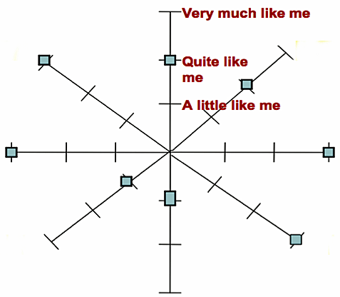

1

*Specific Skill / Subject Reflection*

a

5

*4) Social Skills*

* *Collaborative*
* *Relationship*
* *Intercultural*

*1b) Intrinsic Motivation (SM Affective)*

* *University / Future Goals*

*Specific Skill / Reflection*

4

3

2

c

b

*Specific Skill / Subject Reflection*

*Specific Skill / Reflection*

**SUBJECT AREA**

*2) Thinking Skills*

* *Critical Thinking*
* *Creative/Innovative Thinking*
* *Transfer*

*Specific Skill / Subject Reflection*

*Specific Skill / Subject Reflection*

*1c) Use of my Data and Understanding Feedback (SM Reflective)*

*Specific Skill / Subject Reflection*

*Specific Skill / Subject Reflection*

*3) Communication Skills*

* *Verbal and Non-Verbal*
* *Electronic*
* *Negotiation*