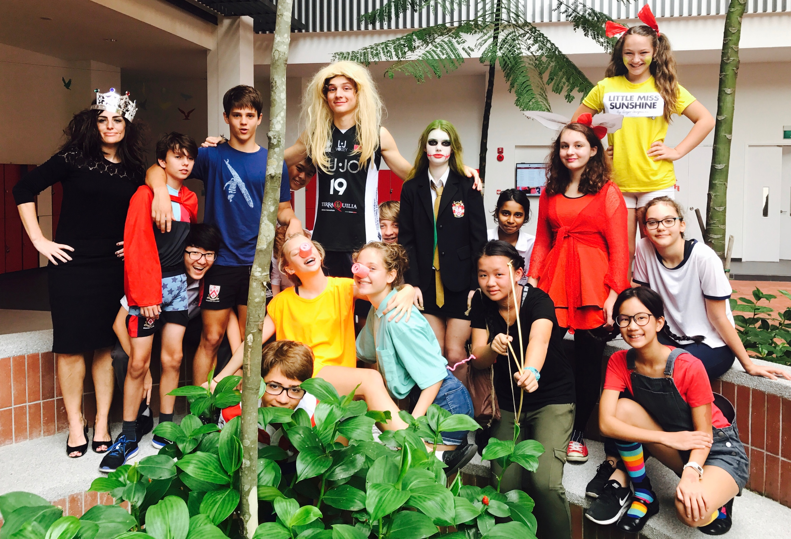
With the school librarians putting on a whole host of activities across the College throughout the week, it was wonderful to see so many students get involved in the many competitions, talks and activities on offer. I particularly enjoyed walking around the College on the Friday, playing “Guess the Character” and talking to students about who they had dressed up as and the books they had come from. However, Friday was more than just an excuse to dress up: Friday was a chance to think about those without such easy access to books and for whom being able to read is not a given.

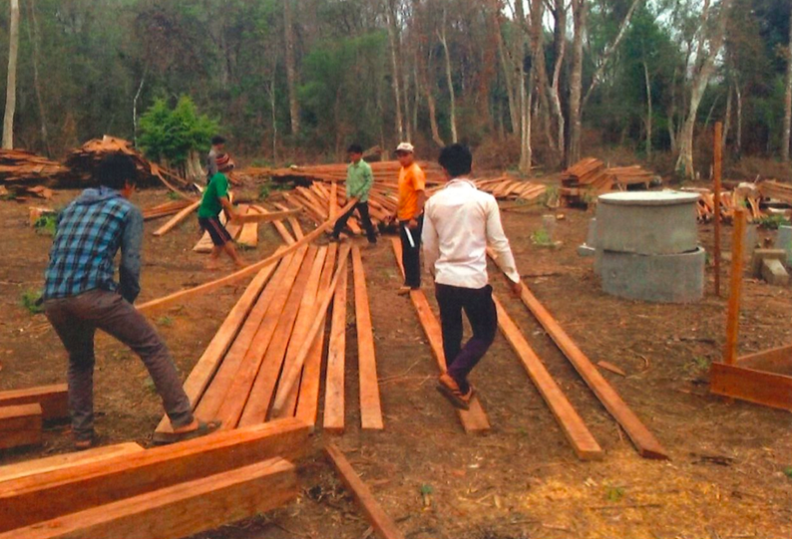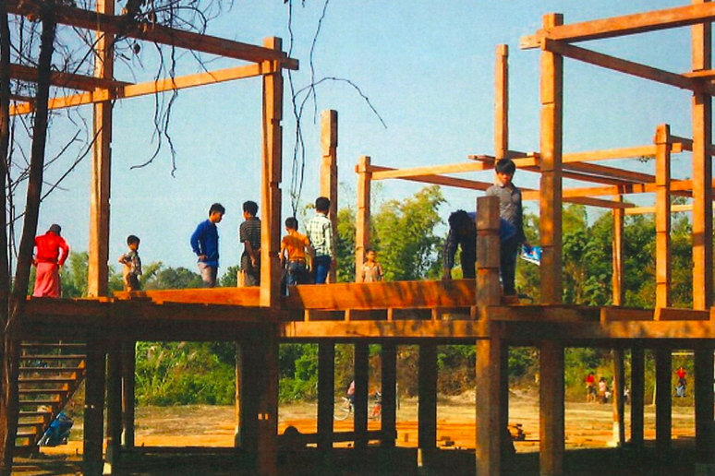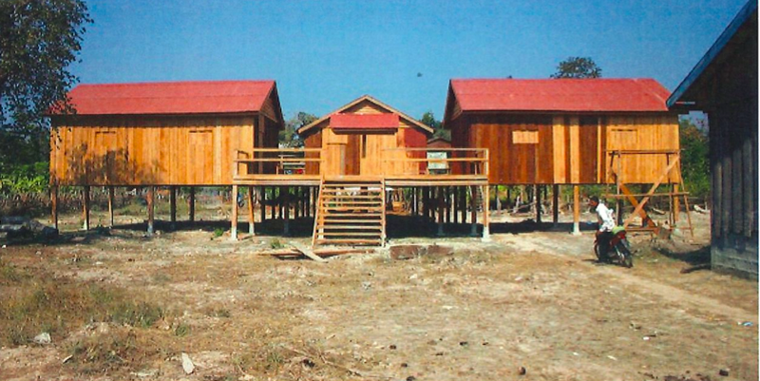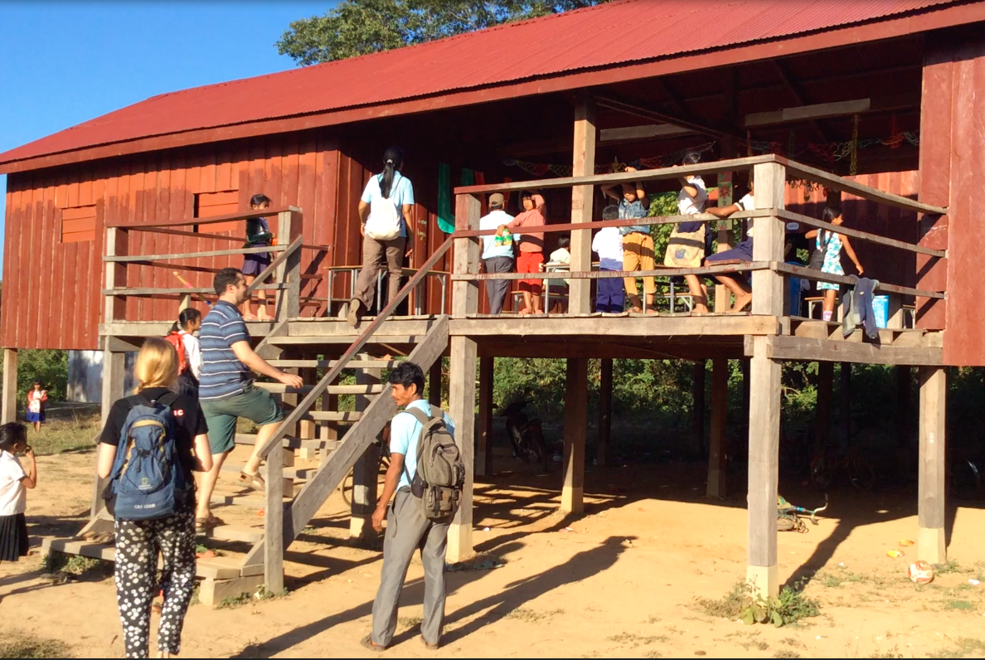
Stages of the school building in Ngang Som Toch since 2014.
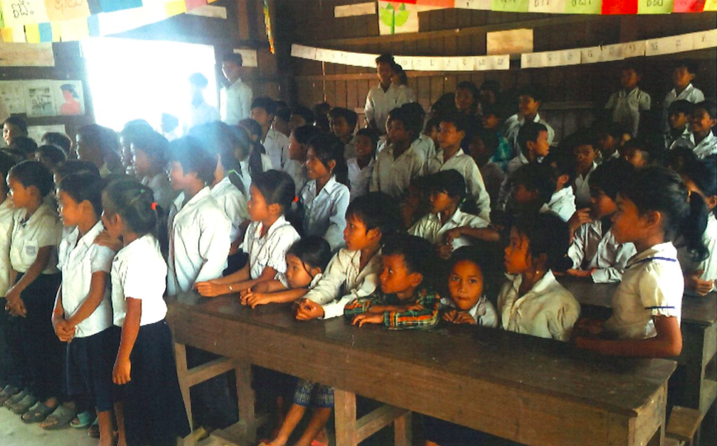
Our partner school, in a very remote part of Cambodia, has now been open for 2 years and growing at an astonishing rate. Back in September they were hoping to have 250 students; by July this year however they already cater to almost 300 students. The number of government and community teachers has increased to 6 and more emphasis is now being put on training the local teachers. Encouraging young girls to stay in education has been a real focus: a crèche is now provided so that many are able to remain in education rather than stay at home to look after their younger siblings. The opening of Ngang Som Toch Primary School has also transformed the whole community: more families have moved to the area to send their children to school which has seen more shops and small businesses set up providing increased employment and families settling more permanently.
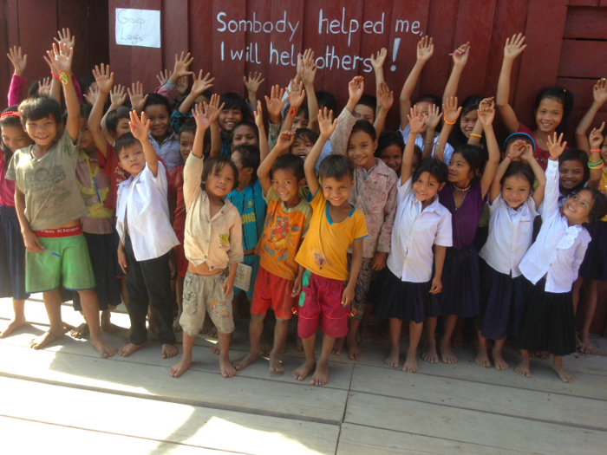
An amazing $2441.90 was raised across the whole college as part of World Book Day. This money will go directly towards helping to maintain and expand the school, provide resources, pay for teachers (and their training) and so much more! It will certainly go a long way in helping ensure that more students in the local areas gets the chance to attend full-time education.

On behalf of all the Community Service team I would like to say a huge thank you to everyone who took part and donated so generously. To find out more about the impact your money has on students in Cambodia please read the two case studies below.

