Red Dot Books 2020 – 2021 on 

Older Readers
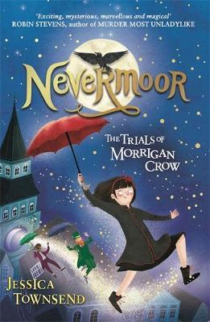  Nevermoor: The Trials of Morrigan Crow | √ Audio Book  × eBook
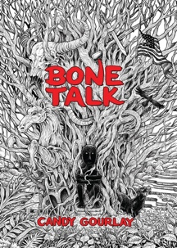  Bone Talk | × Audio Book  √ eBook
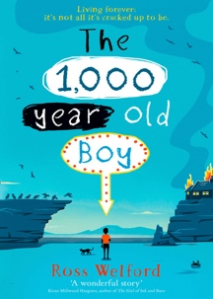  The 1,000-Year-Old Boy | × Audio Book  √ eBook
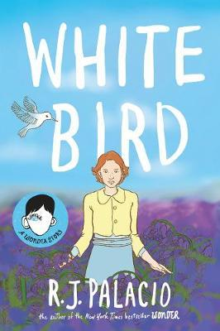  White Bird: A Wonder Story | √ Audio Book  × eBook
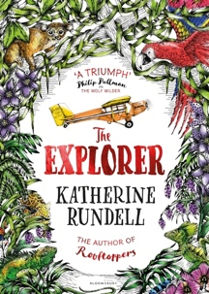  The Explorer | √ Audio Book  √ eBook

Mature Readers
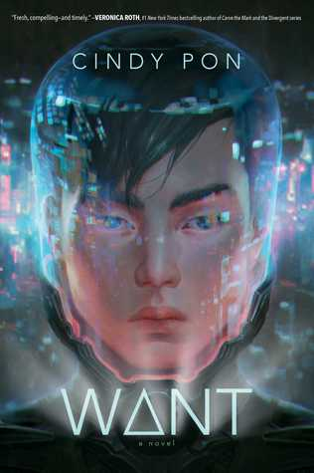  Want | √ Audio Book  × eBook
  The Surprising Power of a Good Dumpling | × Audio Book  √ eBook
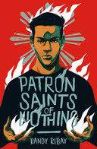  Patron Saints of Nothing | √ Audio Book  √ eBook
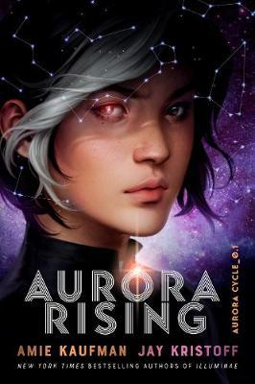  Aurora Rising | √ Audio Book  × eBook
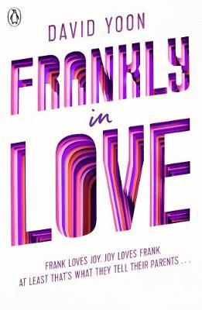  Frankly in Love | √ Audio Book  × eBook

