**Year 9 Examination**

**Biology**

**May 2017**

Name:……………………………………………................

Time allowed: 75 minutes

|  |  |  |
| --- | --- | --- |
| Total Marks available | / 75 | Teacher comment: |
|  | % |
| Level/Grade |  |

|  |
| --- |
| Student reflection |

**Questions**

**Q1.**

A student carries out an experiment to investigate the effect of different concentrations of a food dye on diffusion.

(a)  Describe what is meant by the term **diffusion**.

**(1)**

.............................................................................................................................................

.............................................................................................................................................

(b)  The student adds a different concentration of coloured food dye to each of five wells in an agar plate.

The diagram shows the agar plate at the beginning of the experiment and after 24 hours.

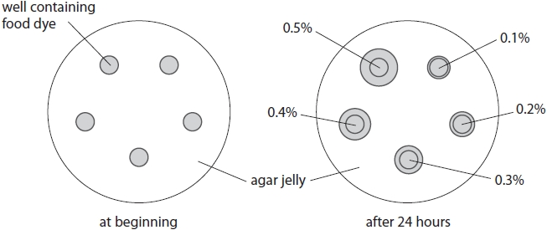

The student does the experiment using three plates.

For each plate he measures the diameter of each circle to see how far the food dye has diffused.

The table shows his results.

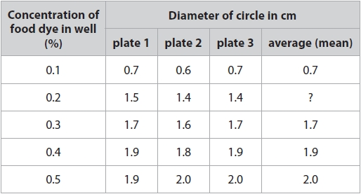

(i)  Calculate the average diameter for 0.2% concentration of food dye.

**(2)**

average diameter = ........................................................... cm

(ii)  Describe the effect of food dye concentration on diffusion.

**(2)**

.............................................................................................................................................

.............................................................................................................................................

.............................................................................................................................................

.............................................................................................................................................

(iii)  Explain the relationship between food dye concentration and diffusion.

**(2)**

.............................................................................................................................................

.............................................................................................................................................

.............................................................................................................................................

.............................................................................................................................................

(c)  State two variables that the student should control in this experiment to ensure that the results are valid.

**(2)**

1 ..........................................................................................................................................

2 ..........................................................................................................................................

**(Total for question = 9 marks)**

**Q2.**

The diagram shows some ciliated cells and goblet cells lining the wall of the bronchioles in the lungs.

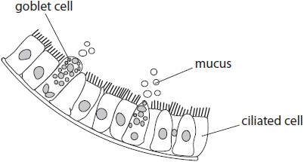

The small hairs on the surface of the ciliated cells are called cilia.

The goblet cells produce mucus. This mucus is moved by the cilia.

(a)  Suggest how ciliated cells and goblet cells protect the lungs from infection.

**(2)**

.............................................................................................................................................

.............................................................................................................................................

.............................................................................................................................................

.............................................................................................................................................

(b)  Chemicals in cigarette smoke reduce the movement of the cilia.

Suggest why people who smoke cigarettes often have to cough.

**(1)**

.............................................................................................................................................

.............................................................................................................................................

.............................................................................................................................................

(c)  A scientist investigates the effect of two brands of cigarette, brand A and brand B, on the movement of cilia.

He uses a single-celled organism called *Paramecium* as a model for cilia movement.

The diagram shows a *Paramecium,* which uses cilia on the outside of its body to move through water.

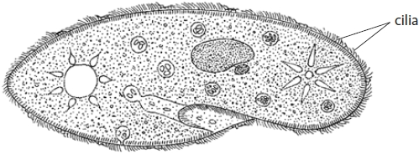

The scientist obtains solutions for each brand of cigarette by placing the tobacco into test tubes of water for 20 minutes.

Chemicals in the tobacco dissolve in the water.

•   he places a *Paramecium* in the solution from brand A  
•   he places a *Paramecium* in the solution from brand B  
•   he also places a *Paramecium* in a control solution  
•   he uses a light microscope to observe the movement of the *Paramecium*

The graph shows his results.

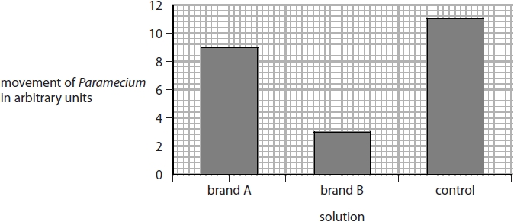

(i)  Describe the effects of the solutions on the movement of the cilia.

**(2)**

.............................................................................................................................................

.............................................................................................................................................

.............................................................................................................................................

.............................................................................................................................................

.............................................................................................................................................

(ii)  What should the scientist use as a control solution?

**(1)**

.............................................................................................................................................

.............................................................................................................................................

(iii)  The scientist concludes that smoking reduces the movement of cilia in human lungs.

Another scientist suggests this may not be a valid conclusion.

Give three reasons why this conclusion may not be valid.

**(3)**

1 ..........................................................................................................................................

.............................................................................................................................................

.............................................................................................................................................

2 ..........................................................................................................................................

.............................................................................................................................................

.............................................................................................................................................

3 ..........................................................................................................................................

.............................................................................................................................................

.............................................................................................................................................

**(Total for question = 9 marks)**

**Q3.**

Lipase is an enzyme that digests lipid into fatty acids and glycerol.

(a)  Name a part of the digestive system where lipase is released.

**(1)**

.............................................................................................................................................

(b)  A drug, X, that inhibits lipase is used to help people lose weight.

Explain how inhibition of lipase helps people to lose weight.

**(2)**

.............................................................................................................................................

.............................................................................................................................................

.............................................................................................................................................

.............................................................................................................................................

(c)  A scientist wants to investigate the inhibition of human lipase using different concentrations of drug X.

The diagram shows the apparatus the scientist uses.

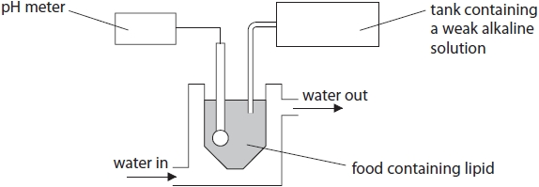

In the investigation one concentration of drug X is added to food containing lipid.

The percentage inhibition of lipase is measured after 10 minutes.

This is repeated using different concentrations of drug X.

Explain which temperature of water should be used in the apparatus throughout the investigation.

**(2)**

.............................................................................................................................................

.............................................................................................................................................

.............................................................................................................................................

.............................................................................................................................................

(d)  A chemical extracted from dandelion plants also inhibits lipase.

The scientist repeats his experiment using the same range of concentrations of this chemical.

The graph shows the scientist's results for drug X and the chemical from dandelion plants.

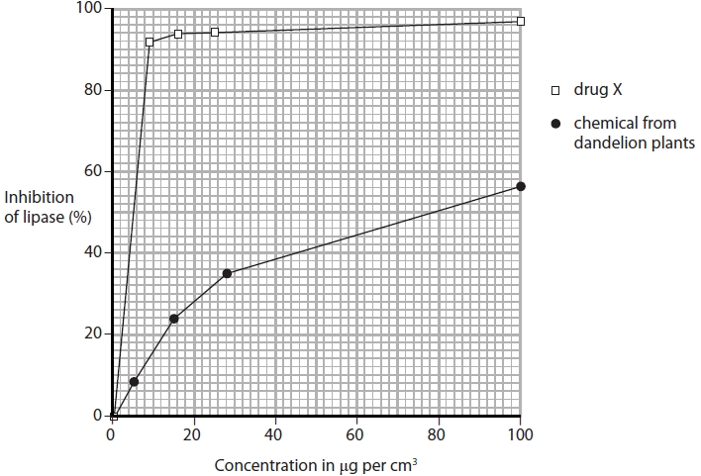

(i)  Calculate the difference between the concentration of drug X and the concentration of chemical from dandelion plant extract that produces 50% inhibition.

Show your working.

**(2)**

difference = ........................................................... μg per cm3

(ii)  Explain how the scientist could use the apparatus from part (c) to tell if the lipase had been inhibited.

**(3)**

.............................................................................................................................................

.............................................................................................................................................

.............................................................................................................................................

.............................................................................................................................................

.............................................................................................................................................

.............................................................................................................................................

.............................................................................................................................................

.............................................................................................................................................

.............................................................................................................................................

(iii)  Why is drug X used at a maximum concentration of 8 μg per cm3?

**(1)**

.............................................................................................................................................

.............................................................................................................................................

**(Total for question = 11 marks)**

**Q4.**

(a)  The table shows features found in three groups of living organisms.

Complete the table using a tick  to show that the group of living organisms shows the feature and a cross  if the feature is absent.

**(4)**

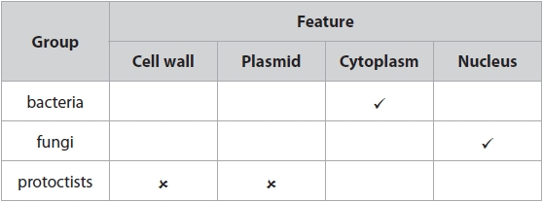

(b)  Some bacteria, fungi and protoctists are pathogens.

(i)  Name another type of pathogen.

**(1)**

.............................................................................................................................................

(ii)  Give an example of a disease caused by a protoctist.

**(1)**

.............................................................................................................................................

**(Total for question = 6 marks)**

**Q5.**

Yeast is a single-celled fungus. The diagram shows a yeast cell with parts labelled A to F.

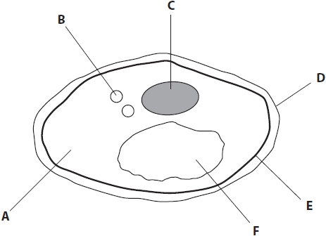

(a)  The table lists functions of different parts of the yeast cell.

Complete the table by giving the letter of the part that carries out the function.

**(2)**

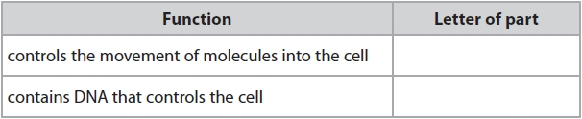

(b)  The table lists statements.

Put a tick  in the boxes next to the statements that are correct for yeast.

**(2)**

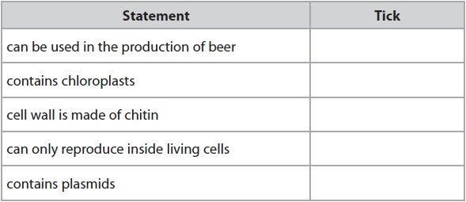

**(Total for question = 4 marks)**

**Q6.**

A group of students investigate the effect of exercise on breathing rate.

They measure their breathing rate at rest by counting breaths per minute.

They then exercise by running on the spot.

After exercise they measure their breathing rate by counting breaths per minute.

These are their results.

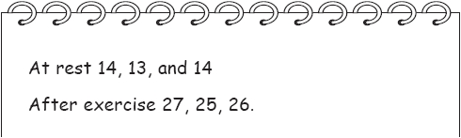

(a)  Display these results in a table.

**(2)**

(b)  Explain why breathing rate is higher after exercise.

**(4)**

.............................................................................................................................................

.............................................................................................................................................

.............................................................................................................................................

.............................................................................................................................................

.............................................................................................................................................

.............................................................................................................................................

.............................................................................................................................................

.............................................................................................................................................

.............................................................................................................................................

.............................................................................................................................................

.............................................................................................................................................

.............................................................................................................................................

(c)  Explain how the students could improve their investigation.

**(2)**

.............................................................................................................................................

.............................................................................................................................................

.............................................................................................................................................

.............................................................................................................................................

.............................................................................................................................................

.............................................................................................................................................

**(Total for question = 8 marks)**

**Q7.**

A student adds oil (lipid) to water.

He then puts drops of the mixture onto a microscope slide.

The diagram shows oil droplets floating on the water, as seen using a microscope.

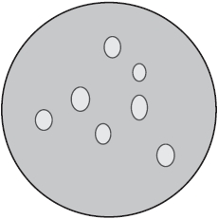

The student then adds different solutions to four separate samples of oil droplets floating on the water.

Diagrams A, B and C show the possible appearance of the oil droplets after each solution is added.

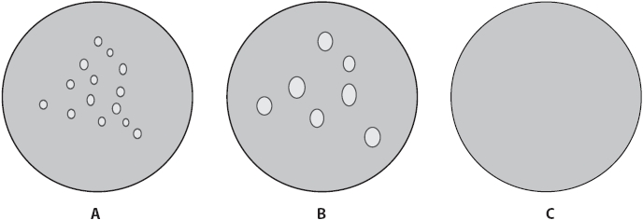

(a)  (i)  The table lists the solutions added to the oil and water mixture.

Complete the table to show which diagram the mixture would look like after each solution is added.

You may use each letter once, more than once or not at all.

One has been done for you.

**(3)**

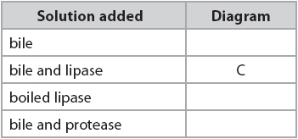

(ii)  Explain why no droplets are seen after bile and lipase solution is added to the oil and water mixture.

**(4)**

.............................................................................................................................................

.............................................................................................................................................

.............................................................................................................................................

.............................................................................................................................................

.............................................................................................................................................

.............................................................................................................................................

.............................................................................................................................................

.............................................................................................................................................

(b)  Starch is digested in the small intestine. The small intestine contains many structures that absorb glucose.

The diagram shows one of these structures.

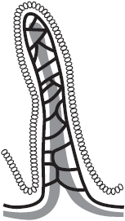

(i)  Name this structure.

**(1)**

.............................................................................................................................................

(ii)  Explain how this structure is adapted to absorb glucose.

**(5)**

.............................................................................................................................................

.............................................................................................................................................

.............................................................................................................................................

.............................................................................................................................................

.............................................................................................................................................

.............................................................................................................................................

.............................................................................................................................................

.............................................................................................................................................

.............................................................................................................................................

.............................................................................................................................................

.............................................................................................................................................

.............................................................................................................................................

**(Total for question = 13 marks)**

**Q8.**

A scientist uses this apparatus to find out if body size affects the rate of respiration in hamsters, which are small mammals.

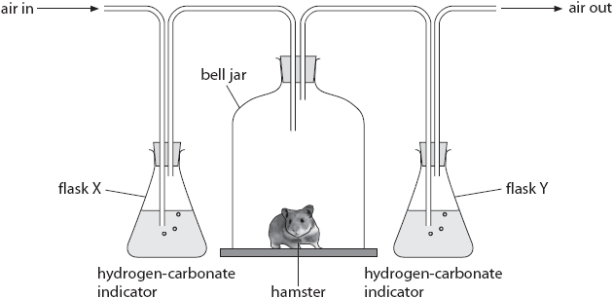

She puts a small hamster into a bell jar and measures the time taken for the hydrogen-carbonate indicator to change colour in flask Y.

She then repeats the experiment with a bigger hamster.

(a)  (i)  State the colour that the hydrogen-carbonate indicator would be in flask X and flask Y at the end of each experiment.

**(2)**

flask X ..................................................................................................................

flask Y ..................................................................................................................

(ii)  Explain the colour change of the hydrogen-carbonate indicator in flask Y at the end of each experiment.

**(1)**

.............................................................................................................................................

.............................................................................................................................................

(b)  The table shows the scientist's results.

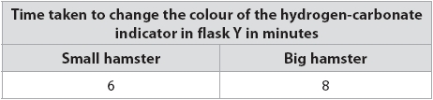

(i)  Hamsters need to maintain a constant body temperature.

Use this information and your knowledge to explain the difference in these results.

**(2)**

.............................................................................................................................................

.............................................................................................................................................

.............................................................................................................................................

.............................................................................................................................................

.............................................................................................................................................

.............................................................................................................................................

(ii)  Explain why hamsters need to maintain a constant body temperature.

**(2)**

.............................................................................................................................................

.............................................................................................................................................

.............................................................................................................................................

.............................................................................................................................................

.............................................................................................................................................

(c)  The scientist's results are not reliable and might not be accurate.

(i)  Explain why her results are not reliable.

**(1)**

.............................................................................................................................................

.............................................................................................................................................

(ii)  Explain why her method might not produce accurate results.

**(1)**

.............................................................................................................................................

.............................................................................................................................................

(d)  Give three variables that the scientist should control in her experiments.

**(3)**

1 ..........................................................................................................................................

.............................................................................................................................................

2 ..........................................................................................................................................

.............................................................................................................................................

3 ..........................................................................................................................................

.............................................................................................................................................

**(Total for question = 12 marks)**

**Q9.**

The diagrams show a root hair cell and a leaf palisade cell.

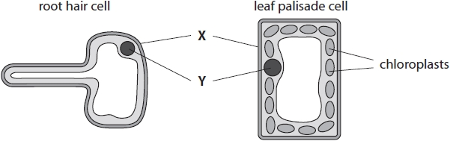

(i)  Complete the sentence by putting a cross () in the box next to your answer.

The part labelled **X** is the

**(1)**

   **A**    nucleus

   **B**    cell wall

   **C**    cytoplasm

   **D**    vacuole

(ii)  Describe the role of part **Y**.

**(2)**

.............................................................................................................................................

.............................................................................................................................................

.............................................................................................................................................

.............................................................................................................................................

**(Total for question = 3 marks)**