**EXAMPLE**

AQA Food Preparation and Nutrition

Food Investigation Assessment NEA 1

Task: The flavour and texture of pastry is important. Investigate the functional and chemical properties of ingredients used to make shortcrust pastry.

[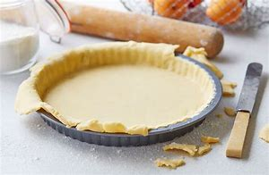](https://www.bing.com/images/search?view=detailV2&ccid=UIZywnJ0&id=B85BC712D670DA7B8891436313D818C32CF36018&thid=OIP.UIZywnJ0uC-V484-2YpwswHaE3&mediaurl=https://realfood.tesco.com/media/images/303-glutenfree-shortcrust-pastry-07c56ebf-3553-4455-a6eb-31f3d167e74e-0-1400x919.jpg&exph=919&expw=1400&q=shortcrust+pastry&simid=608044204993676066&selectedIndex=43&adlt=strict)

Name:

Centre Name:

Candidate Number:

Centre Number:

Task

The flavour and texture of pastry is important. Investigate the functional and chemical properties of ingredients used to make shortcrust pastry.

Task Analysis

To answer the task I will carry out background research into the functional and chemical properties of ingredients used to make shortcrust pastry, particularly types of flour. I will use my prior learning related to pastry making. There are many methods of making shortcrust pastry. When I’ve completed research I will carry out practical investigations based on the functional and chemical properties of ingredients for making shortcrust pastry.

Prior Learning

Fat, flour and water are ingredients used in the rubbing in method to break down the fats and blend with flour using fingertips. Fat contributes to the shortness and tenderness as the fat interferes with gluten formation, meaning the pastry won’t be stretchy.

Research

* **Water** binds ingredients and combines flour (gluten) to form stretchy dough, prevented by fats. If too much water is added the mix becomes too sticky, not enough becomes lumpy. The perfect mix should be smooth meaning water should only be added slowly. Use cold ingredients as water is absorbed much less easily into flour proteins when the temperature is colder slowing down the formation of gluten.
* **Salt** enhances flavour and colour, strengthens gluten. With salt gluten is able to hold more water.
* **Flour** provides structure. Flour can affect the look and texture, for example wholemeal flour gives a darker colour and more gritty texture whilst providing more fibre than other flours.
* **Methods** such as shortening is where the fat is rubbed into the flour and molecules of fat surround the flour particles and exclude water to create a short, crumbly texture. Some methods use a food processor as it creates a fine and thin crumb which creates a short texture.
* **Fats** provide a short crumbly texture and golden colour. Fat prevents the development of gluten, which would shorten the dough. You can change flavour based on the fat such as vegetable shortening, butter and lard. A combination of butter and lard may provide the perfect pastry as it binds easily and has a lovely colour and taste.

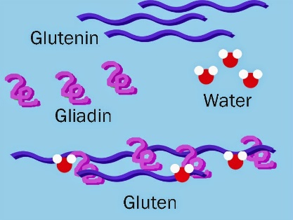

This is gluten is forming. Within shortcrust pastry we don’t want a stretchy dough and therefore we use butter instead of water as it will stop the formation of gluten and leave a strong, not stretchy dough for shortcrust pastry.

Bibliography

<https://getrevising.co.uk/diagrams/fats-in-shortcrust-pastry>

<https://www.bbc.com/food/recipes/shortcrustpastry_1278>

<https://www.s-cool.co.uk/gcse/food-technology/ingredients-and-nutrition/revise-it/functions-of-ingredients>

<https://www.taste.com.au/baking/articles/8-rules-for-perfect-pastry-by-matt-preston/w2vZRFZn>

<http://www.foodafactoflife.org.uk/Sheet.aspx?siteId=19&sectionId=83&contentId=308>

<https://www.bakeinfo.co.nz/Ask-Us/FAQ/Ingredients/What-is-the-role-of-salt-in-bakery-products->

<https://digitalcommons.unl.edu/cgi/viewcontent.cgi?article=1412&context=extensionhist>

**\*For each investigations I will be using the same recipe/method which will be repeated 3 times per investigation, however in Investigation 1 I will change the fat, Investigation 2 I will change the flour, Investigation 3 I will change the water temperature. By using the same recipe/method for each I can assess the different factors of pastry more accurately\***

Equipment

* Food processor
* Measuring spoons
* Weighing scales
* Jug
* Baking Tray

Ingredients

* 125grams of flour
* A pinch of salt
* 55grams of fat
* 2-3 tbsp. cold water

Method

1. Put flour, fat and salt in processor. Pulse until fat is rubbed into flour
2. Add water until dough comes together
3. Wrap dough and chill for 10 minutes

Investigation 1 - Fats

I am going to investigate how changing fats within the mixture can affect texture and flavour. I will produce three pastries with different fat in each. I will assess results based on flavour, texture and colour of the mixture.

Hypothesis

My hypothesis is that the mixture in which lard has been used will give the best texture as it is a shortening agent so will provide a crumbly texture, however I think that butter will provide the tastiest pastry as based on my knowledge butter provides the most flavour within pastry which is why it is the preferred ingredient for recipes. I think that the pastry using butter may provide the most golden colour as the lard and vegetable shortening are quite neutral in colour so may not leave a golden colour.

Fair Test/Controls

To complete a fair investigation I shall control the variables which will mean that each pastry has been produced equally to maintain accurate results

* Independent Variable – Fats (butter, lard, vegetable shortening)
* Dependent Variables - Texture, Colour and Appearance
* Control Variables - Measurements of ingredients, Baking duration, Pastry size, Oven temperature

Method:

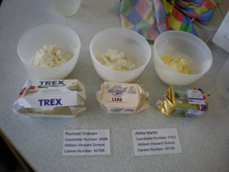

I added 55g of each fat (butter, lard, and veg) to 125g of strong white flour and a pinch of salt in 3 different bowls.

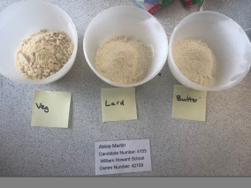

I blended each in a food processor until crumbly

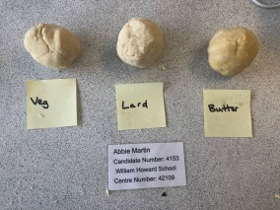

I then added a few table spoons of water to each mixture until the pastry bound together and wasn’t sticky

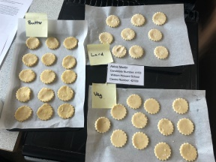

Once bound, I rolled out mix to same thickness before cutting using same cutter and labelled corresponding baking trays

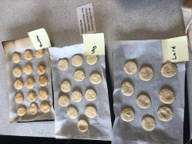

After 20 minutes each of the pastries were cooked. I was able to taste the differences as well as see the appearance

Overall Results

Analysis

I will be assessing flavour, texture, and colour using the ranking method in which **1 will be the least and 5 will be the most** to help me to reach my conclusion as to which fat is the best to use whilst expressing my results.

|  |  |  |  |  |  |  |
| --- | --- | --- | --- | --- | --- | --- |
| **Flavour** | **Sweet** | **Salty** | **Buttery** | **Tasteless** | **Creamy** | **Overall** |
| Lard | 1 | 1 | 1 | 5 | 2 | 1 |
| Butter | 3 | 1 | 5 | 2 | 4 | 5 |
| Veg | 1 | 2 | 2 | 3 | 2 | 1 |

|  |  |  |  |  |  |  |
| --- | --- | --- | --- | --- | --- | --- |
| **Texture** | **Crumbly** | **Soft** | **Gritty** | **Hard** | **Sticky** | **Overall** |
| Lard | 3 | 5 | 1 | 1 | 2 | 4 |
| Butter | 4 | 4 | 1 | 3 | 1 | 5 |
| Veg | 2 | 2 | 1 | 2 | 3 | 3 |

|  |  |  |  |  |  |  |
| --- | --- | --- | --- | --- | --- | --- |
| **Colour** | **Golden** | **Pale** | **Brown** | **Burnt** | **Colourless** | **Overall** |
| Lard | 1 | 5 | 1 | 1 | 5 | 2 |
| Butter | 5 | 1 | 4 | 2 | 2 | 5 |
| Veg | 1 | 5 | 1 | 1 | 5 | 1 |

Conclusion

I believe when making shortcrust pastry the best fat is butter as it has the tastiest flavour, most golden colour and one of the softest textures. However when attempting the experiment again I may choose a combination of lard and butter as based on my research the mix of lard and butter provides the best mix as it provides the colour and taste of butter whilst having the soft crumbly texture of lard as this shortens the dough. I also found vegetable shortening the worst as it provides the mixture with no colour, taste and a slightly sticky mix.

Investigation 2 - Flour

Hypothesis

My Hypothesis is the mixture where Strong White flour has been used will provide the best texture as it isn’t as gritty as wholemeal and will not rise as much as self-raising. However the fibre within wholemeal the dough will be stronger than the others as based on my research the protein content within the flour affects the dough, so the higher the content the stronger the dough.

Fair Test/Controls

* Independent Variable - Flour Self-Raising, Wholemeal, Strong White
* Dependent Variables - Texture, Colour and Appearance
* Control Variables - Measurements of ingredients, Baking duration, Pastry size, Oven temperature

Method same as before but using different flours

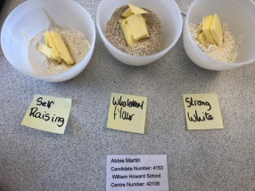

55g butter to 125g each flour (self-raising, wholemeal, strong white) and a pinch of salt. 3 different bowls

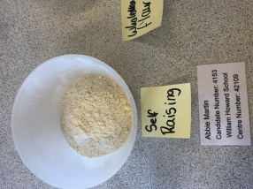

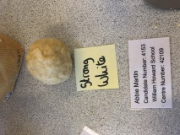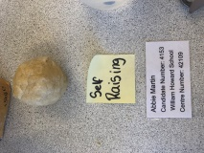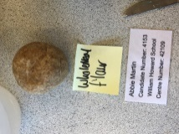

Water to each mixture until the pastry bound together

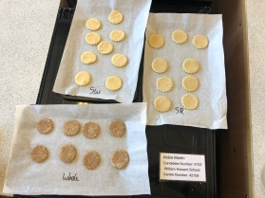

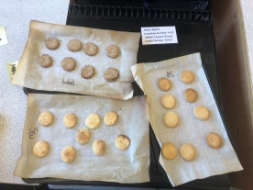

After 20 minutes each of the pastries were cooked and I was able to taste the differences as well as see the appearance

Overall Results

Analysis

I will be assessing flavour, texture and colour using the ranking method.

|  |  |  |  |  |  |  |
| --- | --- | --- | --- | --- | --- | --- |
| **Flavour** | **Sweet** | **Salty** | **Buttery** | **Tasteless** | **Creamy** | **Overall** |
| Wholemeal | 2 | 3 | 1 | 4 | 1 | 4 |
| Self-Raising | 2 | 2 | 4 | 4 | 3 | 4 |
| Strong White | 2 | 1 | 5 | 4 | 4 | 5 |

|  |  |  |  |  |  |  |
| --- | --- | --- | --- | --- | --- | --- |
| **Texture** | **Crumbly** | **Soft** | **Gritty** | **Hard** | **Sticky** | **Overall** |
| Wholemeal | 3 | 1 | 5 | 4 | 1 | 3 |
| Self-Raising | 4 | 5 | 3 | 3 | 1 | 4 |
| Strong White | 4 | 5 | 2 | 3 | 1 | 5 |

|  |  |  |  |  |  |  |
| --- | --- | --- | --- | --- | --- | --- |
| **Colour** | **Golden** | **Pale** | **Brown** | **Burnt** | **Colourless** | **Overall** |
| Wholemeal | 1 | 1 | 5 | 3 | 1 | 3 |
| Self-Raising | 5 | 4 | 4 | 3 | 2 | 4 |
| Strong White | 4 | 3 | 3 | 3 | 1 | 5 |

Conclusion

I believe when making shortcrust pastry the best flour to use is either strong white or self- raising as they both had similar results, however the overall best flour would have to be strong white as you don’ t want your pastry to rise. Strong White produced the nicest and most golden colour out of the flours. I wouldn’t suggest using wholemeal flour for your pastry as it provides a gritty texture and much darker colour. Wholemeal would be ideal for someone lacking fibre as it contain the highest amount and will also provide a healthier pastry. When doing this experiment again I will ensure when cooking the pastry I move the trays around regularly so that they’re all cooked at a more even temperature.

Investigation 3 – Water

Hypothesis

My hypothesis is cold water will provide the best pastry as when referring to my research cold water is absorbed much less easily into the flour proteins, slowing down the formation of gluten making dough less stretchy. I believe warm water will be worst as it will be quickly absorbed into the flour and create sticky, stretchy dough. I don’t believe tap water will make much difference to the mix as it should be reasonably cool and not too warm.

Fair Test/Controls

* Independent Variable – Water temperature (Warm 63°, Tap 14.1°, Cold 3°)
* Dependent Variables - Texture, Colour and Appearance
* Control Variables - Measurements of ingredients, Baking duration, Pastry size, Oven temperature

Method. Same method as before using different temperatures of water.

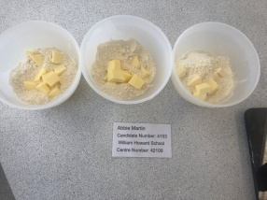

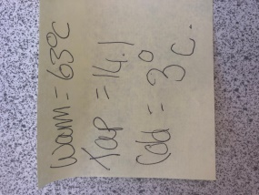

I got three different bowls of water which I prepared at the beginning of my experiment by placing one in the fridge, one with warm water and one with tap water. After that I then used a thermometer to measure the temperature of each water

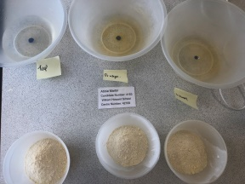

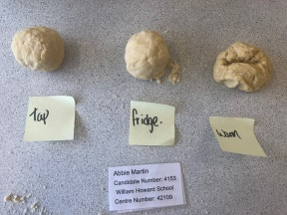

I then added a few table spoons different temperature water to each mixture until it bound together

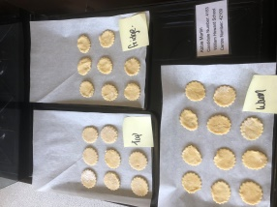

After 20 minutes each of the pastries were cooked and I was able to taste the differences as well as see the appearance. However some of the pastries came out burnt due to the way we placed them which may provide different results. In the future to prevent this I will bake them all on the same shelf

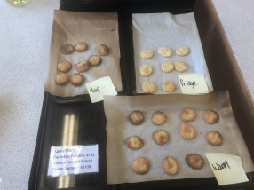

Overall results

Analysis

I will be assessing each factor (flavour, texture and colour) using the ranking method.

|  |  |  |  |  |  |  |
| --- | --- | --- | --- | --- | --- | --- |
| **Flavour** | **Sweet** | **Salty** | **Buttery** | **Tasteless** | **Creamy** | **Overall** |
| Warm | 1 | 2 | 2 | 3 | 2 | 3 |
| Cold | 2 | 1 | 5 | 3 | 5 | 3 |
| Tap | 1 | 2 | 3 | 3 | 2 | 3 |

|  |  |  |  |  |  |  |
| --- | --- | --- | --- | --- | --- | --- |
| **Texture** | **Crumbly** | **Soft** | **Gritty** | **Hard** | **Sticky** | **Overall** |
| Warm | 1 | 2 | 2 | 5 | 5 | 1 |
| Cold | 2 | 4 | 1 | 4 | 2 | 5 |
| Tap | 5 | 5 | 1 | 5 | 2 | 4 |

|  |  |  |  |  |  |  |
| --- | --- | --- | --- | --- | --- | --- |
| **Colour** | **Golden** | **Pale** | **Brown** | **Burnt** | **Colourless** | **Overall** |
| Warm | 1 | 1 | 5 | 5 | 1 | 4 |
| Cold | 4 | 5 | 1 | 1 | 3 | 4 |
| Tap | 1 | 1 | 5 | 5 | 1 | 4 |

Conclusion

I believe when making shortcrust pastry fridge water is the best as it provides a strong pastry due to water being absorbed much less easily into the flour, slowing down the formation of gluten so stays crumbly and short.

Evaluation

I believe for the best shortcrust you must use butter, strong plain flour and cold water because butter provides a nicer flavour and golden colour, strong white flour helps create a strong soft dough and cold water enables the flour proteins to combine much less easily causing less gluten to form, providing a better shorter dough. For someone who requires more fibre I suggest they use wholegrain flour as it contains most fibre and would be the healthiest option in comparison.

If attempting this investigation again I may choose to investigate factors such as different methods. I may also investigate how good each pastry is at holding its shape when a filling is added which will express the strength of the mix. I believe that all investigations went well as each test was fair and can be easily repeated and understood and helped to answer the task. Next time I would check the oven more regularly to avoid risk of burning.

I also now know it is essential to rub the fat into the flour thoroughly so there is no lumps and be careful when adding water as too much can create sticky dough that will be harder to roll out and cut, making a tough mix.

Methods and techniques I have found from the investigations could be used in dishes such as pies, quiches and tarts as they all require a golden and strong pastry in order to hold fillings as well as their shape. A dish requiring a heavy filling such as mince pie will require a stronger pastry and therefore based on my results should use a wholegrain flour as it produced the strongest pastry due to the high amount of fibre. A dish with a light filling, like strawberry tart will require a lighter, softer pastry using strong plain flour which when investigated gave a light yet strong dough. I will use a processor in future for the crumbliest pastry.