

Coffee and conversation with the authors Jessica Duff and Alison Ozawa Sanders

**Friends of Dulwich presents…**

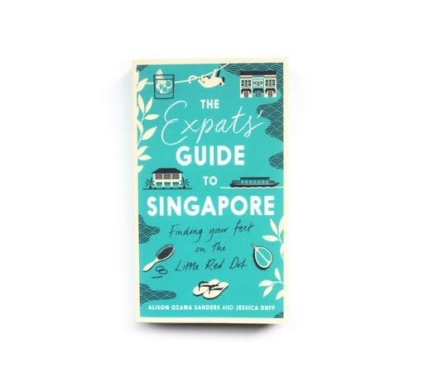



RSVP

Jessica and Alison are co-authors of “The Expats Guide to Singapore: Finding Your Feet on the Little Red Dot”. It is a comprehensive guide to all aspects of expat life in Singapore, which is written in an engaging and humorous way. The book is proving popular with both new arrivals and seasoned expats in Singapore.

Jessica and Alison were previously both lawyers and happy to talk about the process of writing the book, going into business with a friend and work/life balance.

Jessica and Alison will be at the Senior School Library

on Tuesday 19 February 8.45am-9.35am

Tea and coffee served.

Email: [fod@dulwich-singapore.edu.sg](mailto:fod@dulwich-singapore.edu.sg) for more details