Using the Library Catalogue
We have our own online catalogue at Dulwich College, Singapore which you can search anywhere you have internet access:-
https://dcsg.follettdestiny.com/
(The link is also on the student portal)
You can log in your own personal account here to see what books you have out on loan, search the catalogue, reserve books, create your own reading lists and post reviews and recommendations.
- Your log on is your forename.surname
- Password: is your Student ID number on your student pass (omitting the 0s)
If you do not have a log in you can Create your own by entering your Surname and your ID Number
You can personalise the catalogue if you wish and use one of the other designs or formats (either Destiny Quest or Universal Search)
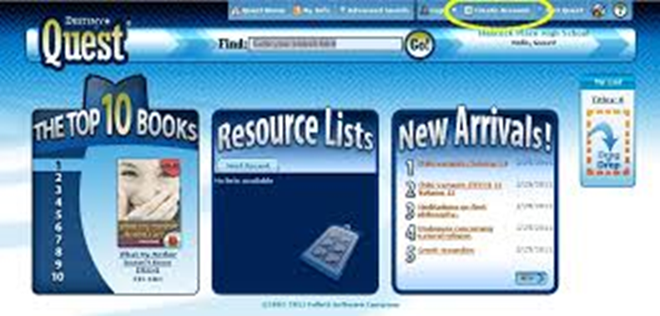
Search the catalogue and select a book you have read or would like to read.

(If you need any further help please contact the librarian: laura.taylor@dulwich-singapore.edu.sg) (P.T.O)
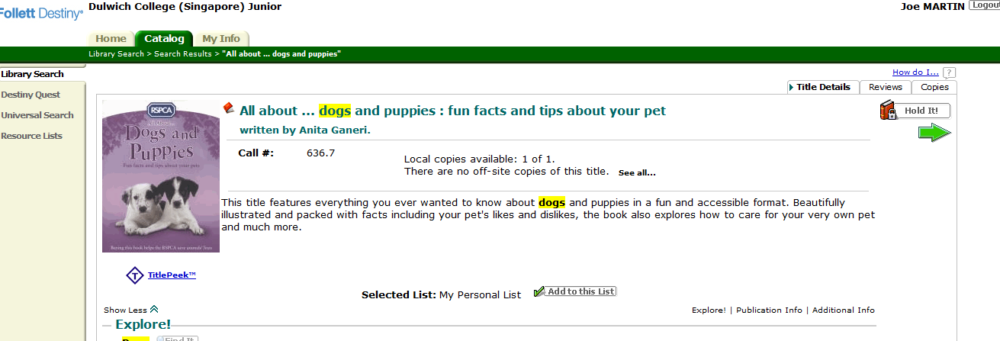
Check to see if there are any reviews already by clicking on the Reviews tab. You can then add your own Star Rating and Comments about the book so other library users can read your recommendations (the review comes to the Librarian for authorisation first before it appears live on the website).
Click on the Hold It tab if you would like to reserve a book. When the book is available the Librarian will contact you to let you know it is save for you to come and collect from the library.

Recommended Reading Lists
The Librarian has created some Recommended Reading Lists for you as part of the Reading Challenge.
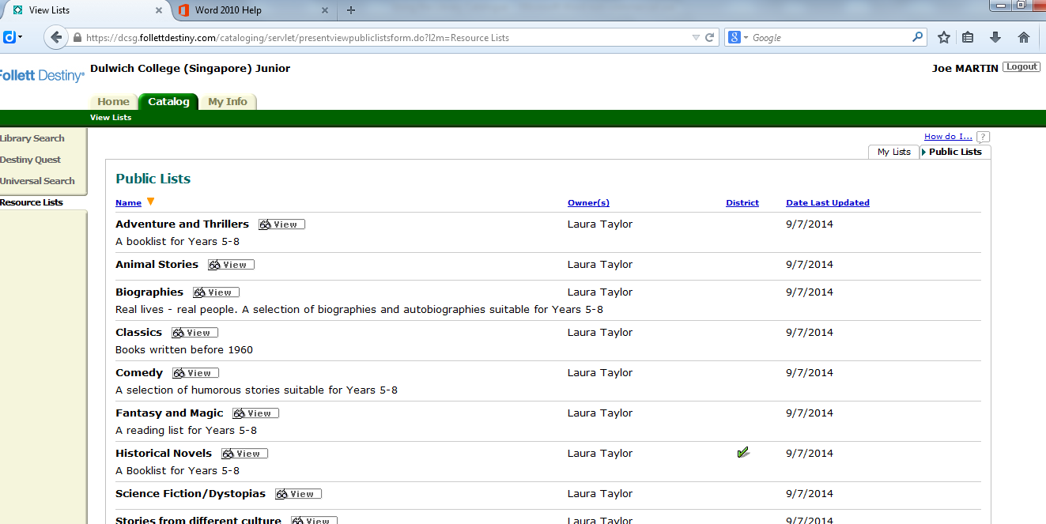
Click on Resource Lists on the left hand side and then Public Lists on the right hand tab to see all the Recommended Reading Lists. You can use them to find book in a particular genre or topic in the library. Don’t forget to post a review when you have read a book from one of these lists.

WebPath Express
Click on this link on the left hand side of the Search page in the Senior catalogue to locate trusted, relevant and age appropriate websites on any topic. You can specify age, grade and reading level to narrow your search

